Assignment 3

***CAPS SOFTWARE Inc.***

***Omar Alam***



**COIS 3030H - Fall 2020**

**Group members:**

**Abhinav Manocha (0658235)**, **Sarah Roy (0650615), Cassandra Yoo (0617214),  
 Punyaja Mishra (0660001)**

# Table of Contents

**Table of Contents** **2**

Project Drivers **3**

The Purpose of the Project 3

Goals of the Business Problem 3

Stakeholder Assessment 5

Priorities Assigned to the Users 6

Project Constraints **8**

Solution Constraint 8

Partner or Collaborative Applications Constraint 8

Off-the Shelf Software Constraint 8

Schedule Constraint 8

Budget Constraint 8

Legal and Ethical Constraint 8

Naming Conventions and Terminology 9

Relevant Facts and Assumptions 11

Scope of the Work 12

Specifying Business Use Cases 15

Data Model and Data Dictionary 36

Scope of the Project 38

Individual Product Use Cases 39

Functional Requirements **57**

Non-Functional Requirements **67**

Look and Feel Requirements 67

Usability and Humanity Requirements 68

Performance Requirements 69

Operational and Environmental Requirements 71

Maintainability and Support Requirements 72

Security Requirements 73

Cultural Requirements 74

Legal Requirements 75

Project Issues **76**

Open Issues 76

Off the Shelf Solutions 76

Risks Assessment 77

Costs 79

Ideas for Solutions 82

# *Project Drivers*

## **The Purpose of the Project**

**Purpose**: Developing a flexible flight-share system that allows passengers to easily choose their flight and destination, and for plane owners to list and share their plane for trips through the convenience of a website or mobile application.

**Advantage**: The system is customizable with a variety of options for the user to choose their flight based on what works with their schedule. The application allows users to input the number of seats they require, departure time, preferred time of arrival, and will present to them all the available flight options for their convenience. The plane owners get the convenience of listing their plane as a mode of transportation.

**Measurement**: Success of this system will be determined by the traffic the application and website sees, as well as how many flights are booked per day through FutureAir. Further indications of the system perform in ideally include net profit, competitive advantage against other companies based on social media presence, customer loyalty, and positive reviews, as well as stock market growth.

## **Goals of the Business Problem**

The aviation sector has been dominated by public planes for air travel in and across countries. To establish a business with a private airline foundation raises pressure. In this ascending pressure, CAPS did a feasibility study to explore all the possible obstructions that can lead to abeyance of this project, and also analyzed all the paths that will expand this business to successful heights.

Our goals for the business problem includes building a successful application and website that is easy to navigate and operate while taking into consideration all the points that can precede slowing of the servers or degrading user-experience.

This is a platform where any plane owner can list their planes for flights after a thorough background check of the owner and maintenance check of the plane. The system will be responsible for efficient communication among the employees and owners for scheduling a comprehensive maintenance of the plane. An unhampered exchange between the business and airport will be maintained for successful flights between cities without any issue regarding the storage space, air traffic, or plane retainment.

The customers looking for a comfortable, private air travel experience can create an account with the system after being verified and they will not only be able to choose any flight according to their convenience, but also have an option of choosing the number of seats, entertainment, meals, and various other catering options. They will have a platform to review their travel experience or voice any concerns they had during the flight. A proper agreement with the government will ensure border and immigration checks.

Another part of the business goal includes CAPS ensuring a firm and non-negotiable firewall security. Packet filtering and inspection will be accurate to keep all the user data safe and clean.

## **Stakeholder Assessment**

**Client**

FutureAir is the client paying for CAPS to develop the application and website.

**Customer**

FutureAir is also the customer buying our system in order to utilize it for their company.

**Hands on Users of the Product**

Passengers are the users of the system who will be booking and catching flights. The system must be accessible and cater to passengers who might speak any language, passengers with physical or mental disabilities, and easy enough for passengers who may not be familiar with modern technology.

Plane owners are the individuals who will be using the system to list their own planes for flights. Plane owners will have the responsibility of choosing whether the plane will take multiple stops to drop off and pick up passengers.

Government personnel involved with the system include border control, customs, and immigration. These users will be heavily involved during international travel and are responsible for handling the relevant paperwork for flights that cross borders.

Maintenance officers/engineers will be notified and scheduled through the system to perform inspections and keep planes in top condition. Field office agents will be the individuals hired through FutureAir to interact with the system as well as both passengers and plane owners. The field office agents will go through the necessary training to aid passengers in booking and cancelling flights, and help plane owners list their planes for flights.

Flight crew are those that include the pilot, co-pilot, flight navigator, and flight attendants. The crew will be notified through the system to determine which flights they must provide their services for.

**Other Stakeholders**

Airports will work with the system to exchange flight details and will provide accessible boarding for all passengers.

Black hat hackers are intelligent individuals who have negative and malicious intentions in hacking and exploiting the system.

Developers will work in a team to create and deliver the system by February 2021.

## **Priorities Assigned to the Users**

The priorities assigned to users have been divided into three parts - key users, secondary users, and unimportant users.

1. **Key Users**

*Plane Owners:*

The plane owners are the users that drive this product. Plane owners after being verified post their planes on the product which is the attraction for more users/customers - the passengers.

*Passengers:*

Passengers are the “customers” of the product and the success measure of the product.

1. **Secondary Users**

*Authorities working for FutureAir:*

The authorities and staff of FutureAir are responsible for handling reports and making sure all operations run smoothly. They have an important role but their reviews do not affect the product.

*Government Agents:*

The staff hired are in alliance with the government to ensure the product abides by the laws and regulations, and ensures the verification of identification documents. They have an important role but their reviews do not affect the product.

*Immigration Agents:*

The immigration agents are responsible for the verification of documents for international travel. They have an important role but their reviews do not affect the product.

*Airport Agents:*

The airport agents are responsible for verification of tickets and boarding passes for every passenger. They have an important role but their reviews do not affect the product.

*Technicians and Maintenance engineers:*

They are the skilled staff safeguarding the flights by maintaining every plane. They have an important role but their reviews do not affect the product.

*Hospitality Staff:*

The crew for the plane like air hostesses, catering, cleaning and etc. They are the skilled users with an efficient role but their reviews do not affect the product.

1. **Unimportant Users**

*Legal experts:*

Legal experts are required whenever there is a conflict with any flight, documents and there is a violation of any law and regulations. They are the temporary users of the product and their reviews and actions do not affect the product at all, making them an unimportant user.

*Labor for monthly checks of the product:*

The developers and designers of the product update and check the product every month to certify that the product is good to run. They do not affect the functioning of the product, except possibly the design if they decide to update the product.

*Users (mostly passengers) that have an account but never use it/book any planes:* Sometimes some users log onto the product and create an account but do not use the product. They act like the spectators and do not affect the product in any way.

# *Project Constraints*

## **Solution Constraint**

* The application being developed should be available on desktop as well as both iOS and Android devices.
* Following few optimization guidelines for shorter response rate.
* Using minified Javascript and module bundling as language for shorter code that can be parsed faster.
* The use of existing open-source applications or databases to develop the project may have capacity limitations or hinder the speed of the system.

## **Partner or Collaborative Applications Constraint**

* The product shall interface with air traffic control or weather stations.
* The product shall maintain proper communication with airports in the flight destination cities to ensure less air traffic or accidents.

## **Off-the Shelf Software Constraint**

* Any partnership with a bank for processing of payments.
* Associating with the government for verification of identity and international flight documents.

## **Schedule Constraint**

* The project has to be developed by February 2021.

## **Budget Constraint**

* The budget available for development of the system is CAD 20 million.
* Financial constraints due to the rising environment sustainability issues caused by flying.
* Financial constraint produced by the inadequate information about the employees’ effort or quality which hinders from borrowing against their labor income.

## **Legal and Ethical Constraint**

* Operating within International Aviation Law to maintain relations between nations.
* All the conveyance should follow the Aviators Model Code of Conduct.

## **Naming Conventions and Terminology**

| **Name** | **Definition** |
| --- | --- |
| Application | An online program or system that performs a certain task or a set of tasks. |
| Authorities | A governmental agency or corporation to administer a revenue-producing public enterprise. |
| Aviation | Operation of an aircraft pertaining to airplane manufacture, development, and design. |
| Client | A person or organization that pays to use the services provided by a professional person or company. |
| Constraints | A limitation or restriction faced during the development of a project. |
| Customer | A person or organization that purchases a commodity or service. |
| Developer | A person or company that develops computer software. |
| Engineers | A trained professional who runs or supervises an engine or an apparatus. |
| Field offices | A position of responsibility or some degree of executive authority. |
| Field office agents | Trained officers who interact with the system as well as both passengers and plane owners. |
| Fuel Company | Business entities that engage with the exploration, production, and refinement of oil and gas to airplane companies. |
| Goals | The object of a person/company ambition or effort; aim or desired result. |
| Inspectors | Trained professionals who keep the planes in top condition. |
| Maintenance | The process of preserving and keeping a project/task up-to-date. |
| Measurement | A unit or system utilized to quantify an amount. |
| Naming convention | Allow useful information to be deduced from the names based on a specific document or regularities. |
| Net profit | The actual profit after working expenses not included in the calculation of gross profit have been paid. |
| Open-source | A software where the source code is freely available for possible modification and redistribution. |
| Oversight | An inadvertent omission or error. |
| Restrictions | A limiting condition or a control on something or someone. |
| Scope | The defined features and functions of a product needed to finish a project. This involves getting information required to start a project, and the features the product would have that would meet its stakeholders requirements. |
| Stakeholder | A person with interest or concern in a business. |
| Technicians | A person/company employed to maintain technical equipment or a person skilled in the art of science. |
| Transportation | To carry goods/people from one place to another. |
| User | A person or company who uses/operates a business. |
| Traffic | A concentration of users or participants in a server that may impede the system’s speed. |
| Unrealistic | Not feasible within a time frame. Inappropriate to reality or fact. |
| Weather station | A station for taking, recording, and reporting meteorological observations to aircraft operators and pilots. |

## **Relevant Facts and Assumptions**

*Relevant Facts*

* The product will confirm the scheduling of planes.
* One plane owner can not have two of their flights leaving at the same time, the plane owner has to be present in their plane to ensure honesty and integrity.
* There will be communication between the plane owner and the passenger to decide on the multiple stop and drop-off locations (if applicable).
* Plane owners will be responsible for ensuring that their plane reaches the airport on time. Lateness will lead to fees charged to the plane owners.
* Plane owners will be responsible for scheduling and fueling of their planes. FutureAir holds no responsibility in this process.

*Business Rules*

* The pilot and crewmates hired via the application will not have two successive flights within 10 hours if their first flight was more than 8 hours duration.
* Identification and travel documents of every user who has an account with FutureAir will be stored under strong security in FutureAir database
* Staff hired by FutureAir such as technicians, maintenance engineers, Airport agents, immigration agents, government agents, will be paid by the payroll software being used by the FutureAir.
* No sudden changes will be allowed in the shifts of the plane crew like pilot and hospitality staff.

*Assumptions*

* Planes will not face trouble at the borders of countries for an international flight.
* Hangar Space at every airport will be at least 50x40x100 ft in dimensions.
* The weather department’s forecasts will be transmitted according to the specification 1003-7 issued by its engineering department.
* The passengers being ‘picked up’ by the plane owner will successfully reach the pickup point on their own.
* The software responsible for financial transactions will be developed for developers to use and install in the product.

## **Scope of the Work**

*The Context Diagram*

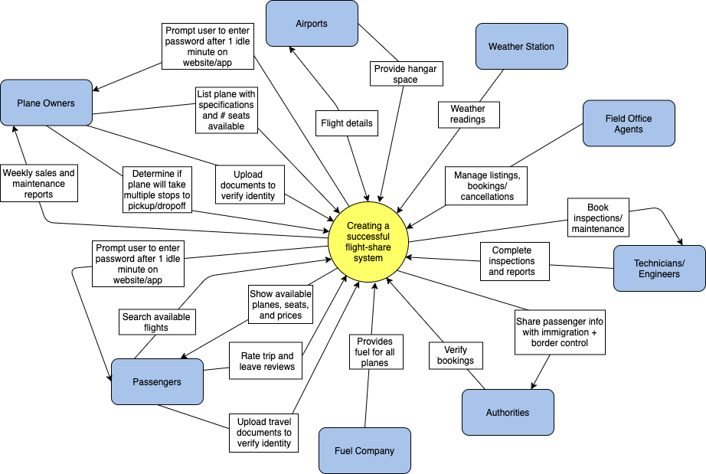

*Figure 1: Context diagram that shows the relationship between the system and all adjacent systems.*

*Work Partitioning (Business Events and Input/Output)*

| **Business Event** | **Input/Output and Business Use Case** |
| --- | --- |
| Airport exchanges flight details with the system. | *Input and Output.*  Airport receives flight details from the system, and the airport sends verified details back to the system. |
| Airports provide hangar spaces for planes. | *Input.*  Planes will take off and arrive at airports and have a designated area to park the aircraft. |
| Weather station provides weather details. | *Input.*  Weather station will transmit details on the weather which will be received by the airport and flight crew. |
| Field office agents provide assistance with plane listings, bookings, and cancellations. | *Input.*  Agents will be available to help both passengers and plane owners with the system. |
| Technicians and engineers hired for maintenance or inspection of the planes through the system. | *Output.*  Technicians and engineers will be notified through the system of any tasks they need to perform. |
| Technicians and engineers complete inspections and reports. | *Input.*  Technicians and engineers will complete inspections and report the condition of the plane. |
| Authorities verify bookings with the system. | *Input.*  Authorities verify that the passenger paperwork is complete and verify their booking with the system. |
| Passenger information is shared with authorities for international flights. | *Output.*  Authorities will receive passenger information and verify that all information is correct. |
| Fuel company provides fuel for all planes. | *Input.*  Field Engineers fill up the fuel tanks of planes with fuel provided by the fuel company. |
| Passengers upload travel documents to verify identity. | *Input.*  Border control verifies identities and associated documents. |
| Passengers use the system to search available flights. | *Input.*  Flight information and baggage details are provided within the system which allows users to plan their trips accordingly. |
| Passengers view the available flights along with the number of seats on the plane and the price of the flight. | *Output.*  The system provides access to the passengers to available flights and seats available. |
| Passengers can leave reviews and rate trips. | *Input.*  The online application gains customers and builds a strong reputation through online ratings and reviews that users provide. |
| System prompts passengers to re-enter their password after one idle minute on the application or website. | *Output.*  The system will ask the user to re-enter their credentials after a minute of idle activity for security measures. |
| Plane owners upload documents to verify their identity. | *Input.*  The system securely receives documentation from users which is then verified with the border control authorities. |
| Plane owners list their planes with the specifications of the aircraft and the number of seats available. | *Input.*  Plane owners will upload information about their aircrafts along with the number of seats for listing. |
| Plane owners decide whether the flight will take multiple stops to drop off and pick up passengers on the way to the destination. | *Input.*  Plane owners are responsible for determining the course of the flight and which airports the plane will stop at. |
| Plane owners receive weekly sales reports. | *Output.*  Plane owners will receive weekly sales reports depending on how often their plane was flown. |

## **Specifying Business Use Cases**

1. **Business Event: Airports provide hangar spaces for planes.**

**Business Use Case:** Planes will take off and arrive at airports and have a designated area to park the aircraft.

**Trigger:** Pilot air traffic confirmation of departure or arrival of the aircraft.

**Preconditions:** Airport hangar space must be available for the scheduled plane and verified with the system.

**Interested Stakeholders:** Airport ground control agents, airport tower control agents, security.

**Active Stakeholders:** Airport ground control agents, airport tower control agents, security.

**Normal Case Steps:**

1. Pilot conveys air traffic confirmation of departure of arrival of the aircraft to the weather station and airport tower control agents.

2. The airport tower control agents immediately deliver the information to the airport

ground control agents to prepare for plane departure or arrival.

3. Airport ground control agents review the most updated schedule for the allotted planes, runways and hangar space and approve the departure or arrival of the plane.

**Outcome:** The pilot will successfully land the plane and have a designated area to leave the aircraft.

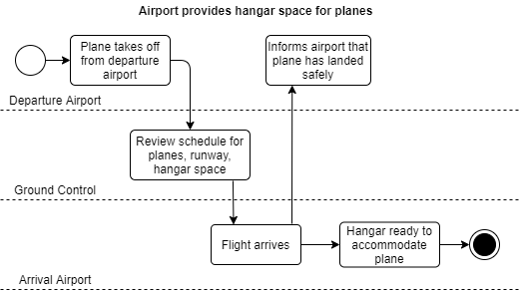

1. **Business Event: Weather station provides weather details.**

**Business Use Case:** The weather station will transmit details on the weather which will be received by the airport and flight crew.

**Trigger:** Unusual weather conditions, scheduled flight taking off.

**Preconditions:** Weather measuring instruments must be adjusted prior to taking precise temperature and wind readings.

**Interested Stakeholders:** Passengers.

**Active Stakeholders:** Pilot, aircraft engineers, tower control agents.

**Normal Case Steps:**

1. Engineers calibrate weather instruments.
2. Engineers take measurements and relay that information to tower control agents.
3. Tower control officers immediately communicate the pilot of the readings.

**Outcome:**  The ground engineers will keep a record of all weather variations and provide the pilots with that information, who will have a better understanding of whether flying is safe or not depending on the conditions.

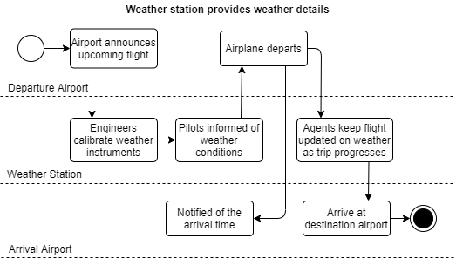

**3. Business Event: Field office agents provide assistance with plane listings, bookings, and cancellations.**

**Business Use Case:** Agents will be available to help both passengers and plane owners with the system.

**Trigger:** Passengers wish to book a ticket with FutureAir, and require assistance.

**Preconditions:** The passenger must want to book a ticket and should have an issue they would like resolved.

**Interested Stakeholders:** Airport agents, security.

**Active Stakeholders:** Field office agents, passengers.

**Normal Case Steps:**

1. A passenger/owner must approach a field office agent to seek help.

*E1.1* The passenger/owner cannot locate a field officer.

1. The customer/owner and agent come to a resolution.
2. A copy of the interaction reported.

**Outcome:** The customer/owner reaches a conclusion and the problem is resolved.

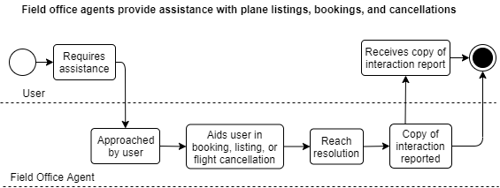

1. **Business Event: Technicians and engineers hired for maintenance or inspection of the planes through the system.**

**Business Use Case:** Hired technicians and engineers inspect and maintain the plane.

**Trigger:** New plane listing on the app/website by a plane owner.

**Preconditions:** Owner should have a verified account, owner should have posted plane details.

**Interested Stakeholders:** Plane owners, passengers, airport agents.

**Active Stakeholders:** Technicians, aircraft engineers.

**Normal Case Steps:**

1. Plane owner lists the flight details on the app/website.
2. Plane owner schedules a meeting with hired technicians and engineers in the area.
3. Technicians and engineers inspect the plane on the day of the scheduled meeting.

**Outcome:** The inspection of the plane that has been listed by the owner is scheduled and started.

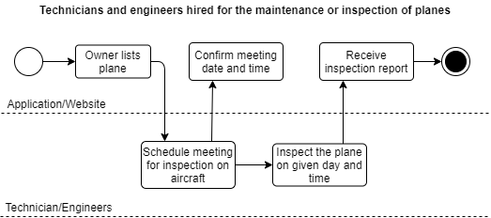

**5. Business Event: Technicians and engineers complete inspections and reports.**

**Business Use Case:** Technicians and engineers make maintenance reports about the plane after inspections.

**Trigger:** New plane listing on the app/website, scheduled meeting for inspection.

**Preconditions:** A meeting scheduled between plane owners and technicians and engineers.

**Interested Stakeholders:** Passengers, airport agents.

**Active Stakeholders:** Plane owner, technicians and engineers.

**Normal Case Steps:**

1. The scheduled meeting for inspection has started.
2. Technicians and engineers inspect the plane.
3. They write a report on the plane.
4. A report copy is given to the plane owner and another copy of the report is saved on the flight profile on the app/website.
5. The report is to the airport agents via the app/website.

**Outcome:** The flight details of the plane that is listed on the app/website is now inspected and all the required details are now in the system. These full details can be sent to the Airport agents for further verification.

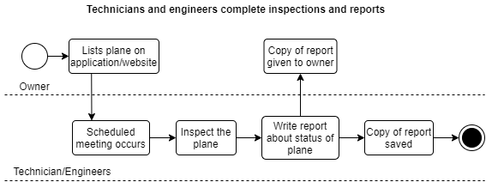

1. **Business Event: Airport exchanges flight details with system.**

**Business Use Case:** The airport receives flight details from the system, and the airport sends verified details back to the system.

**Trigger:** Owner flight confirmation through app/website, flight details.

**Preconditions:** Owner must have documents to verify his plane ownership and details about the pilot and plane’s maintenance report.

**Interested Stakeholders:** Airport agents, security, destination and departure country’s immigration system, baggage handling, airport ground and tower control agents.

**Active Stakeholders:** Airport agents, airport ground and tower control agents, plane owners.

**Normal Case Steps:**

1. Owner enters his/her flight details on the website along with the reports received from the inspection by the technicians and engineers.
2. The flight details are sent to the Airport for verification.
3. Ensure that the owner is correctly identified and has proper ownership documents for the plane.

*E3.1* The owner details can not be verified.

1. Ensure whether the flight is maintained properly and can be allowed to fly.

*E4.1* The flight is not in condition to fly.

1. Ensure whether the flight is free to use the airport space with the provided details.

*E5.1* The airport space is not available as requested.

1. Record and allocate the flight number and details into the flight schedules for the day.
2. Airport confirms or denies if the hangar space and runway is available for operation and passenger booking confirmation.

**Outcome:** The airport verifies documentation with the concerned reservation, immigration and flight information authorities and notifies the system that the airport is ready for operation or not. Airports will record and allocate hangar space for the flights and provide confirmation of the space through the system.

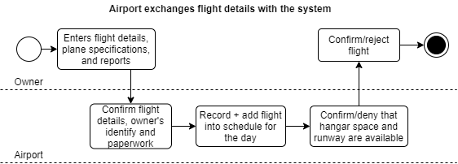

**7. Business Event: Authorities verify booking with the system.**

**Business Use Case:** Authorities verify that the passenger’s required paperwork is complete and verify their booking with the system.

**Trigger:** Immigration and border control review passenger’s paperwork.

**Preconditions:** Passenger must have a passport and proper documentation to cross a border if entering another country.

**Interested Stakeholders:** Passenger, immigration/border control, airport agents.

**Active Stakeholders:** Passenger, immigration/border control.

**Normal Case Steps:**

1. Passenger uploads passport, visa, and other documentation onto the application/website.
2. Immigration officers log in to their respective accounts and verify the documents with their servers.
3. Immigration officers/agents record the verification onto the website.

**Outcome:** The immigration officers/agents are responsible for verifying the documents and alerting FutureAir servers of any fraudulent or misleading information that pertains to the passengers’ identity or status. The officers provide proper verification and documentation of the immigration status of all the passengers.

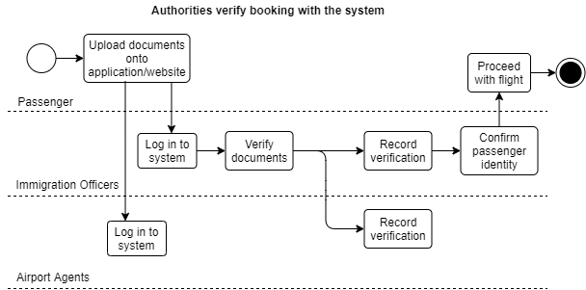

**8. Event: Passenger information is shared with authorities for international flights.**

**Business Use Case:** After booking a flight and entering all information on the app/website, the passenger’s information is sent to authorities for international flights.

**Trigger:** Passenger creates account on app/website, passenger tries booking a seat on a plane on app/website.

**Preconditions:** The plane the passenger is trying to book the seat for should be listed and scheduled, the passenger should have an account before booking a seat.

**Interested Stakeholders:** Passenger, owner, authorities.

**Active Stakeholders:** Passenger, authorities.

**Normal Case Steps:**

1. Passenger looks for a plane and tries booking a seat after they find the perfect plane for them.

*A1.1* Passenger may simply make an account before looking for a plane.

1. Passenger makes an account on the app/website and enters all required information.
2. Passenger books a seat on the plane.
3. The passenger information and booking information is sent to the authorities.

**Outcome:** Authorities receive the passenger information along with their booking information for a scheduled flight and the information is verified and stored in the database. This information will be needed during the boarding of the flight by the passenger to verify it is the same passenger who booked and not someone else.

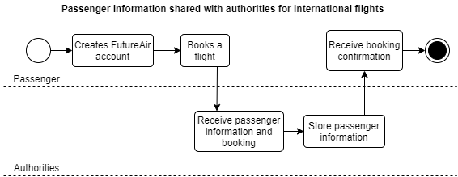

**9. Business Event: Fuel company provides fuel for all planes.**

**Business Use Case:** Before a scheduled plane departs, the fuel company ensures that the plane is adequately fueled.

**Trigger:** A plane is scheduled to depart, a fuel company has been booked to fuel the plane.

**Preconditions:** The details by the plane owner should be verified, the plane listed should be approved and scheduled by the airport, the fuel company must be notified of the schedule and the plane.

**Interested Stakeholders:** Fuel company, plane owner, airport agents, pilot (if the plane owner is not the pilot), plane staff (if any), maintenance engineers.

**Active Stakeholders:** Fuel company, plane owner, airport agents.

**Normal Case Steps:**

1. Plane has been scheduled/ approved to take flight.
2. Plane owner books an appointment with the fuel company before the scheduled flight time.
3. The plane is fueled on the scheduled time.

*A3.1* There is a delay from the scheduled time in fueling leading to a delay in flight.

1. The plane is fueled up and ready to depart.

**Outcome:** The plane is filled up on fuel before it departs ensuring no accidents in air.

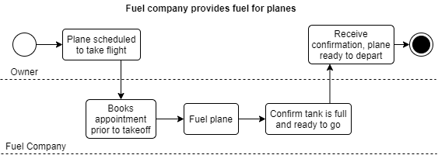

**10. Business Event: Passengers upload travel documents to verify identity.**

**Business Use Case:** When the passengers want to book a flight, they need to upload travel documents on the app.website like visa, passport, any kind of permit (work, travel or study) if applicable.

**Trigger:** Passenger searches for a flight. When they find a perfect flight, they book a seat for the plane, they need to submit documentation for verification. Depending on if the flight is international, the documents might include visa and permits.

**Preconditions:** The plane the passenger is trying to book a seat on should be scheduled already. There should be available seats on the scheduled plane.

**Interested Stakeholders:** Passenger, airport agents, plane owner, international border government agents.

**Active Stakeholders:** Passenger, airport agents, international border government agents.

**Normal Case Steps:**

1. Passenger searches for a flight.
2. Passenger finds the appropriate flight matching their demands.
3. Passenger tries to book a seat but is prompted to make an account or sign in on the app/website.

*E3.1* The passenger will not be prompted to make an account on the app/website if they already made an account and have signed in before searching for flights.

1. Passenger starts booking a seat on the desired flight.
2. Passengers enter the details like name, contact details that they want on the flight, seat choice and other information. The passenger is then asked to upload important verification and travel documents.
3. The documents are sent for verification.

**Outcome:** The passenger uploads the travel documents for verification when booking a seat on a scheduled flight. 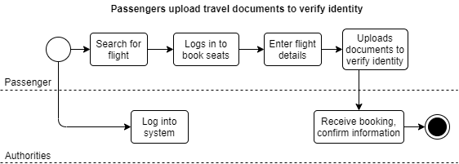

**11. Business Event: Passengers use the system to search available flights.**

**Business Use Case:** Passenger browses through the app/website to search for a scheduled flight that matches the best with the passenger’s demands and comfort.

**Trigger:** Passenger wants to take an urgent trip or needs a flight for business or any personal purpose. The passenger heard about the flight sharing system app/website by FutureAir, or they had a good experience the last time they used FutureAir and want to use it again.

**Preconditions:** The passenger should want to search flights for an urgent trip. There should be scheduled flights with proper details.

**Interested Stakeholders:** Passenger, FutureAir.

**Active Stakeholders:** Passenger, FutureAir.

**Normal Case Steps:**

1. Passenger opens the app/website and enters the destination he/she wants to go to.
2. The available/scheduled flights are presented.

*A2.1* There are no available/scheduled flights for the entered destination.

*A2.2* The passenger enters an alternative destination or stops looking on the app/website.

1. The passenger checks each flight details and looks for particulars like availability of a specific seat, meal plan, entertainment options and so on.

**Outcome:** The passenger searches for flights and either he/she finds the perfect flight and books a seat on the flight or does not find any desirable flight.

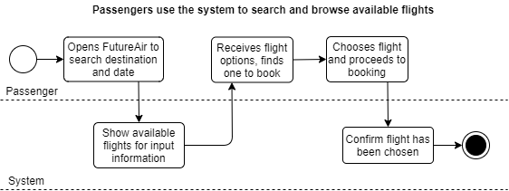

**12. Business Event: Passengers view the available flights along with the number of seats on the plane and the price of the flight.**

**Business Use Case:** When looking for flights, passengers can look at the number of seats available on the seat along with the price of those seats.

**Trigger:** Passenger wants a plane, owner listed his/her plane and has to enter the information about the seat and price after being verified.

**Preconditions:** The listed flight is verified.

**Interested Stakeholders:** Passenger, plane owner, immigration agent.

**Active Stakeholders:** Passenger, plane owner.

**Normal Case Steps:**

1. Passenger opens the app/website to look for any available flight.
2. The passenger finds a desired flight.
3. Passengers view the number of seats left/available and the prices of each seat.

**Outcome:** Passengers look at the available seats and their prices and can decide on whether or not they want to book a seat with FuturAir.

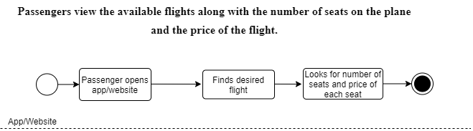

**13. Business Event: Passengers can leave reviews and rate trips.**

**Business Use Case:** After the passenger travelled with a plane owner on FutureAir, they can rate their travel and give reviews on the plane owner’s profile.

**Trigger:** Any experiences a passenger had on the travel and wish to share or give reviews.

**Preconditions:** Passenger travelled with the plane owner they are rating or giving review to, the flight travel has finished.

**Interested Stakeholders:** Passenger, plane owner, new passenger planning on traveling with the reviewed plane owner**.**

**Active Stakeholders:** Passenger traveled, plane owner being reviewed.

**Normal Case Steps:**

1. Passengers book a seat on a flight.
2. The flight had a successful trip.
3. Passengers decide to give review and rating to the plane owner because of their good/poor experience, or simply because they wish to leave a review.

*A3.1* The passenger can choose to only rate and not give any review.

**Outcome:** The passenger after a flight can rate and give reviews to the plane owners they travelled with.

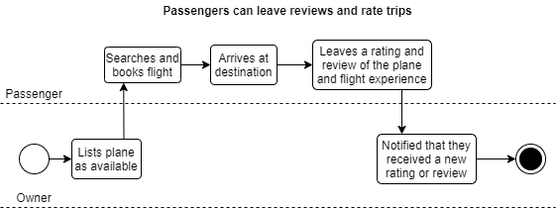

**14. Business Event: System prompts all users to re-enter their password after one idle minute on the application or website.**

**Business Use Case:** For security reasons, after one minute of inactivity on the website or application, the user, if has an account, is asked to re-enter password.

**Trigger:** One minute of inactivity by the application or website user.

**Preconditions:** an account with FutureAir, logged into the FutureAir account on the application or website, one minute of inactivity by the account holder.

**Interested Stakeholders:** User of the account.

**Active Stakeholders:** User of the account.

**Normal Case Steps:**

1. The user has an account with FutureAir.
2. The user is logged into their account on the application or website.
3. The user leaves the page unused for one minute.

*A3.1* There is a network issue and the application or website has an inactivity of one minute.

1. The user is requested to re-enter the password.

**Outcome:** Upon inactivity of one minute, the user has to enter the password again to ensure security.

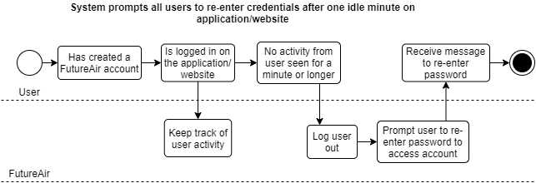

**15. Business Event: Plane owners upload documents to verify their identity.**

**Business Use Case:** When creating an account and listing their plane, plane owners have to upload their verification documents.

**Trigger:** A user tries to list a plane on the application or website as he/she tries to make an account.

**Preconditions:** A user must start creating an account, a user must be listing a plane.

**Interested Stakeholders:** Plane owner, passengers, verification agents.

**Active Stakeholders:** Plane owners, verification agents.

**Normal Case Steps:**

1. A user who wishes to list their plane starts creating an account.
2. The user is asked to upload identification documents for verification.
3. The user uploads the identification documents for verification.

**Outcome:** A new user who is a plane owner uploads identification documents for verification on the application or website.

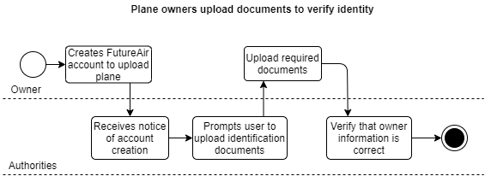

**16. Business Event: Plane owners list their planes with the specifications of the aircraft and the number of seats available and other information.**

**Business Use Case:** Plane owners who list their plane on the application or website have an option to list the specifications like type of plane, number of seats, types of seats, any other services being provided like catering, entertainment, hospitality.

**Trigger:** The plane listed has been verified and scheduled, there are specifications that can be provided and the plane owner wishes to provide them.

**Preconditions:** The plane whose specifications are going to be listed by the plane owner has already been verified and scheduled for departure.

**Interested Stakeholders:** Plane owner, passenger, catering staff, entertainment staff, hospitality staff, cabin crew, pilot.

**Active Stakeholders:** Plane owner, passenger.

**Normal Case Steps:**

1. The plane owner lists a plane that gets verified and scheduled.
2. The plane owner adds more specifications about the plane like type of plane, number of seats, types of seats, any other services being provided like catering, entertainment, hospitality.

*A2.1* The plane owner can choose to add only a few of these specifications or none.

1. The information is updated on the plane listing on the website or application.

**Outcome:** The plane owner is able to add extra specifications and details to help passengers make a better discussion and give them better experience.

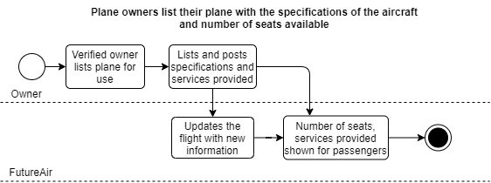

**17. Business Event: Plane owners decide whether the flight will take multiple stops to drop off and pick up passengers on the way to the destination.**

**Business Use Case:** The plane owners get the power to choose how many stops their plane will make and where.

**Trigger:** The plane owner has passengers from different cities lying within or just a little deviated from the original route and passengers have requested for stops.

**Preconditions:** There are requests by passengers to stop while booking, the plane is listed and scheduled.

**Interested Stakeholders:** Passengers, plane owner, airport agents, private runways or stops owners.

**Active Stakeholders:** Passengers, plane owners.

**Normal Case Steps:**

1. The Plane owner has listed a plane that has been verified and scheduled.
2. The passengers have booked a seat on that plane and have requested stops for pickup and dropoff.
3. The plane owner processes their requests and decides they want to make the stops.

*A3.1* The plane owner does not want to make the stops.

*A3.2* The plane owner might miss the request or forget to respond to the request before a certain time (usually two days of request). The request is automatically set to denied and the optional message is set on “No response”.

1. The plane owner clicks on accept and sends an optional message with any details to the passenger along in the notification.

*A4.1* Since the plane owner is not making the stops, they choses denied and send an optional message to the passenger explaining the reason they denied their stop request.

1. The passengers get a notification that their request has been accepted with an optional message.

*A5.1* The passenger gets the notification that their request has been denied with an optional message.

**Outcome:** The passenger is able to request for stops during the booking and the plane owner can choose to accept or deny their request.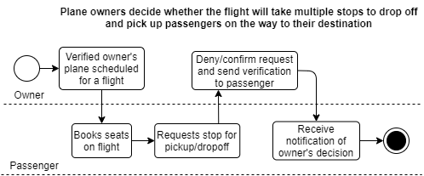

**18. Business Event: Plane owners receive weekly sales reports.**

**Business Use Case: The plane owners receive weekly reports about their flights to the FutureAir database.**

**Trigger:** A week is completed since account formation or last weekly report.

**Preconditions:** The plane owner has been a member of FutureAir for more than a week at least.

**Interested Stakeholders:** Plane owner, FutureAir.

**Active Stakeholders:** Plane owner, FutureAir.

**Normal Case Steps:**

1. The plane owner has completed a week since being a member on FutureAir or since last weekly report.
2. The plane owner receives the weekly report document provided by FutureAir on the application or website on his/her account. This document includes information like what flight listed, how many passengers booked on the flight, flight number, flight details, flight travel experience, flight travel problems faced, staff used on the flight.

*A2.1* The plane owner might not have had a flight listed yet or the flight is yet to depart. They will simply be sent “no report” notification.

*A2.2* The plane owner has objection about some information on the report, the plane owner “sends objection”.

**Outcome:** The plane owner submits a weekly report to FutureAir. This helps FutureAir keep track of the flights and also make any possible improvements.

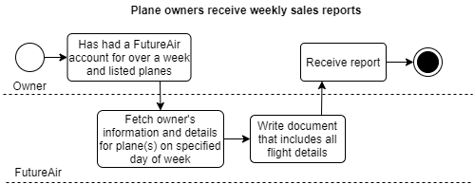

**19. Business Event: User creates their account on FutureAir.**

**Business Use Case:** The user needs to create an account for various reasons.

**Trigger:** A plane owner has to create an account to list his/her plane. A passenger has to create an account to book a seat. An agent or staff has to create an account as their job profile.

**Preconditions:** FutureAir up and running, plae owner has a plane to list, passenger wants to book a flight, staff has been hired, users have all of their identification and verification documents ready.

**Interested Stakeholders:** Plane owners, passengers, staff.

**Active Stakeholders:** Plane owners, passengers, staff.

**Normal Case Steps:**

1. Once the FutureAir application or website is up and running, all the users will want to create an account.
2. Users click on either the create account or sign up button.
3. Users start entering details like - First Name, Last Name, Date Of Birth, Address, Province, City, Country, Zip Code, Contact Information (Mobile Number, Email, Alternate Mobile Number), Card Information.
4. Users are prompted to upload identification documents.
5. The uploaded documents are then sent to the FutureAir Database where the agents verify them.
6. Once the documents and identity has been verified, the user owns their account.

*A6.1* The documents could not be verified. The documents entered were not clear. User is prompted to upload clear documents again. Then Normal Case Step 6 happens again.

*A6.2* The documents could not be verified. The documents belong to a user with a questionable background or some bad background.

*A6.3* The documents could not be verified. The documents contain false information.

1. A notification is sent to the user saying their information has been verified and is prompted to complete his/her account formation steps.

*A7.1* The documents contained questionable background so a meeting is scheduled with the user to confirm this and decide on the steps to be taken further.

*A7.2* The documents contained false information. Legal actions are taken immediately.

1. The user enters Username, Password, Confirm Password and hits the “Create” button.
2. The user has created an account and now is a member of FutureAir.

**Outcome:** Users have an account created with FutureAir.

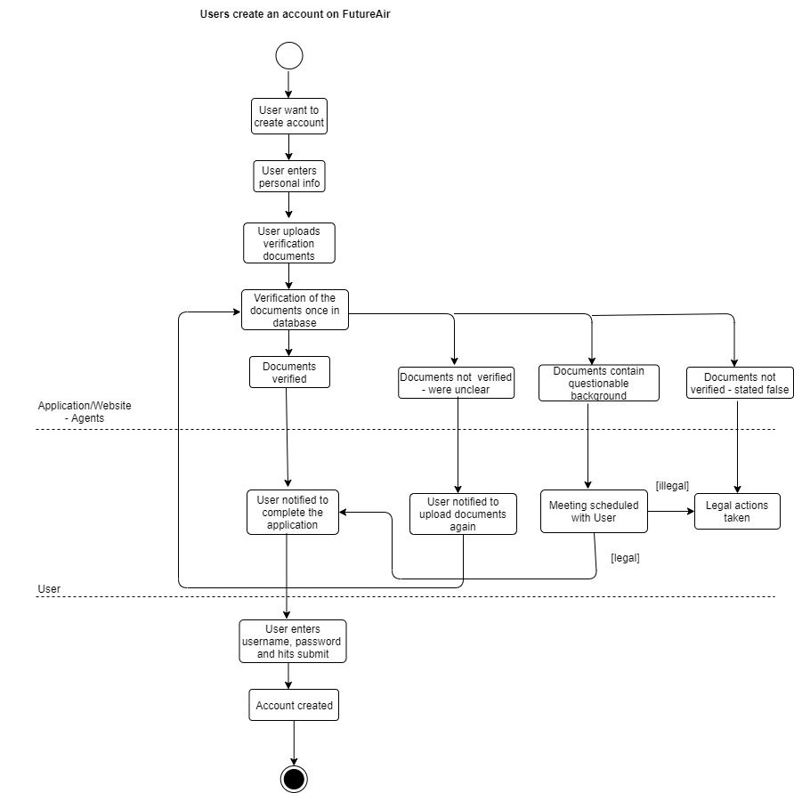

**20. Business Event: Planes will take off and arrive at airports and have a designated area to park the aircraft**

**Business Use Case:** Planes associated with FutureAir are provided hangar space at the airports they are taking off from.

**Trigger:** Scheduled plane has approached the scheduled time to take flight

**Preconditions:** Plane needs to be scheduled

**Interested Stakeholders:** Plane owner, airports, airport agents, Pilot

**Active Stakeholders:** Plane owners, pilot, Airports

**Normal Case Steps:**

1. Plane owners have a scheduled time for the plane to take off.
2. Before the flight, the plane is taken to the airport where it is taken to park at the designated area

**Outcome:** The planes with FutureAir have hangar space at the take off airports.

## 

## **Data Model and Data Dictionary**

*Data Model*

### 

*Figure 2: Data Model diagram that shows the relationships and multiplicity between classes within the database.*

*Data Dictionary*

| **ID** | **Name** | **Content** | **Type** |
| --- | --- | --- | --- |
| 1 | Airports | Airport Identifier + Airport Code + Airport Name | Class |
| 2 | Booking | Booking Identifier | Class |
| 3 | Field agents | Agent Identifier Agent Name | Class |
| 4 | Maintenance Engineer | Engineer Identifier + Engineer Name | Class |
| 5 | Maintenance engineer | Maintenance Identifier + Maintenance Form Identifier | Class |
| 6 | Passengers | Passenger Identifier + Passenger Name | Class |
| 7 | Pilot | Pilot Identifier + Pilot Name | Class |
| 8 | Plane | Owner Identifier + Plane Identifier + Maintenance Identifier | Class |
| 9 | Plane Owners | Plane Identifier + Ower Identifier + Maintenance Identifier | Class |
| 10 | Weather station | Reading Time + Temperature Measurement | Class |
| 11 | Airport Code | Listed in Flight Booking - Airport code that uniquely identifies the airport | Attribute/element |
| 12 | Arrival Airport Code | Listed in Flight Booking | Attribute/element |
| 13 | Arrival Time | 24-hour clock format of the time of arrival of the flight | Attribute/element |
| 14 | Arrival Airport Name | Listed in Flight Booking | Attribute/element |
| 15 | Available seats | Numerical number of vacant seats on an aircraft | Attribute/element |
| 16 | Departure Airport Code | Listed in Flight Booking | Attribute/element |
| 17 | Departure Time | 24-hour clock format of the time of arrival of the flight | Attribute/element |
| 18 | Departure Airport Name | Listed in Flight Booking | Attribute/element |
| 19 | Passport No | Passport Identifier | Attribute/element |
| 20 | Pilot License Number | Pilot identification document | Attribute/element |
| 21 | Temperature Reading | Measured in Celsius and Fahrenheit | Attribute/element |

## **Scope of the Project**

*Product Boundary (Product Use Case Diagram)*

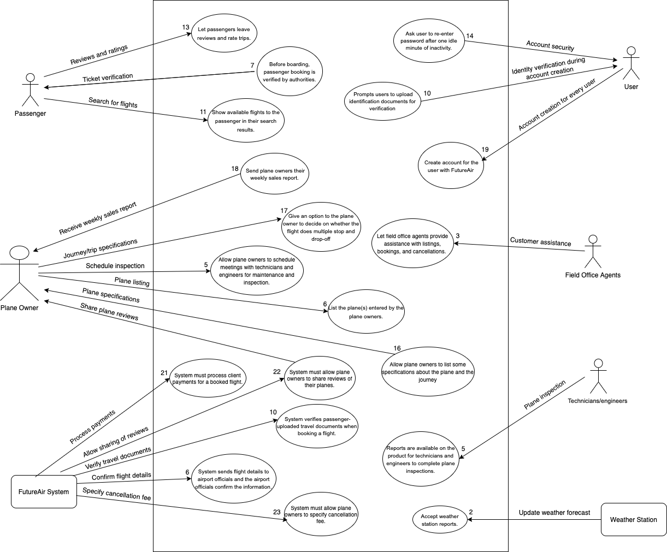

## **Individual Product Use Cases**

**1.** **Product Use Case Name:** System verifies passenger-uploaded travel documents when booking a flight.

**Trigger:** Passenger selects a flight.

**Preconditions:** The plane must be scheduled to fly out and there must be seats available on the chosen flight.

**Interested Stakeholders:** Passenger, airport agent, plane owner, international border government agents.

**Actor:** Passenger

1. The passenger chooses the flight they would like to fly with.
2. The system prompts the passenger to log in or create an account when booking a seat if the user is not already logged in.
3. The passenger enters personal information such as name, contact information, seat choice, drop off location.
4. System asks the passenger to also upload government issued documents to verify their identification.

**Outcome:** The passenger will upload identification and personal information to the system when booking a seat on a flight, the system verifies the information, and allows the passenger to proceed to the payment of the flight.

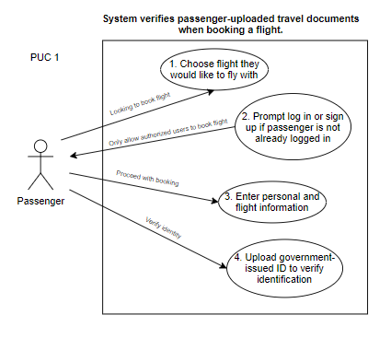

**2. Product Use Case Name:** Show available flights to the passenger in their search results.

**Trigger:** Passenger has an account created in FutureAir and wishes to search for available flights.

**Preconditions:** Passenger should already have an account.

**Interested Stakeholders:** Passenger, plane owner, authorities.

**Actor:** Plane owner

1. Plane owner, after verification, lists their plane on FutureAir.
2. Passenger, after the account has been created, searches for these available flights. Passengers can list the required criteria - from and to destination in the search form available at the top of the page. Further search criteria (optional) that the passenger can choose to enter for more filtered results are time of departure/arrival, round trip/one-way and price range.
3. The request is processed and all the flights with those departure and arrival destinations, and/or nearby departure and destination are displayed to the passenger along with their prices. The priority of the list is according to the latest time, lowest distance between the mentioned places, in the same order.
4. The passenger can click on any result and look for more information about them.

**Outcome:** The system is able to provide filtered available flights to the passengers to choose from.

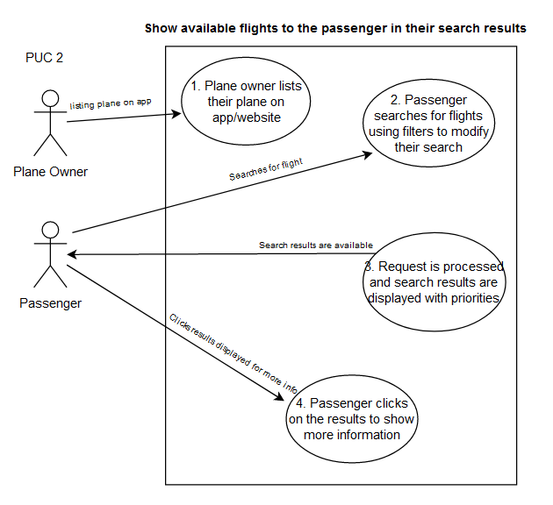

**3. Product Use Case Name:** Let a passenger leave reviews and rate trips.

**Trigger:** Passenger, after a trip or experience with another user of FutureAir, wishes to leave reviews and/or rate the trips they were on.

**Preconditions:** The passenger should have an account with FutureAir.

**Interested Stakeholders:** Passenger, Plane owner.

**Actor:** Passenger

1. After a trip that Passenger can choose to leave a review and/or rate the trip on the plane owners’ profile.
2. A section in their account page will be “past flights”, where the information about the flights the passenger already took will be listed.
3. The passenger chooses the trip they would like to rate.
4. Upon choosing, they will be taken to another page with comment boxes and stars to rate the trip.
5. If submitted, the review/rate will be added on the specific plane owner’s page.

**Outcome:** The passenger can be given satisfaction by allowing them to voice their concerns while plane owners can get feedback to improve or continue hospitality.

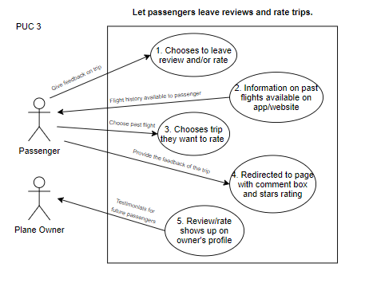

**4. Product Use Case Name:** Ask users to re-enter password after one idle minute of inactivity.

**Trigger:** One minute inactivity by user.

**Preconditions:** User must have an account.

**Interested Stakeholders:** Any user, security.

**Actor:** User

1. A user is using an account.
2. User stops working on the account.
3. One minute of inactivity by the user, a pop-up box will appear asking the user to re-enter the password.
4. If the password is entered correctly, the user will be taken back to their page with saved changes. For three wrong tries, the user will be logged out and get an email signifying the suspicious activity, with a reset password link.

**Outcome:** Security of personal information activity of the user is ensured.

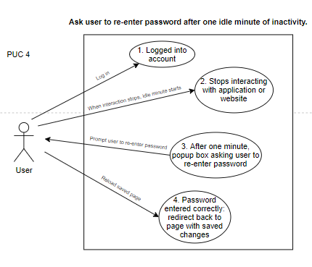

**5. Product Use Case Name:** Prompts users to upload identification documents for verification

**Trigger:** Account formation with FutureAir by any user.

**Preconditions:** User should have started account formation.

**Interested Stakeholders:** User, Authorities, Agents.

**Actor:** User

1. A user wants to create an account for FutureAir. Users enter personal information like first name, last name, contact information, date of birth, username, password and other personal information.
2. Users are prompted to upload identification documents.
3. Once uploaded, these documents are sent to the Authorities and agents accounts
4. The authorities and agents verify the documents.
5. If the submitted documents are approved, the user is taken to a page to enter their card details, and successfully have an account created.
6. If the submitted documents are not approved, legal actions are taken against them depending on the seriousness of the situation.

**Outcome:** The users are now identified and the user account is successfully created.

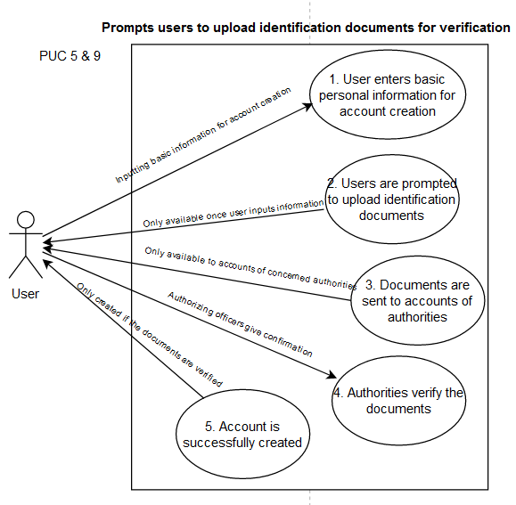

**6. Product Use Case Name:** List the plane(s) entered by the plane owners.

**Trigger:** The plane owner would like to register their plane for availability and flight options.

**Preconditions:** The plane owner must previously have an account with FutureAir.

**Interested Stakeholders:** Plane Owners, security, website developer.

**Actor:** Plane owners

1. A plane owner logins in or creates an account they have made with FutureAir.
2. Plane owners enter their personal information such as first name, last name, contact information, date of birth, password, and other information including their travel documents and information about the plane(s) they would like to register.
3. The authorities will check the information that has been provided and relay that information to a database where it can be stored for security purposes.
4. Once the information is verified, the plane(s) the plane owner registered can be now available for flight.

**Outcome:** The plane(s) is/are now registered under the correct plane owner.

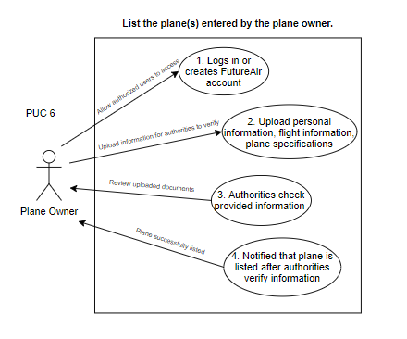

**7. Product Use Case Name:** Send plane owners their weekly sales report.

**Trigger:** Plane owners have a verified account created.

**Preconditions:** The plane owner account has been active more than 7 days.

**Interested Stakeholders:** Plane owner.

**Actor:** Plane owner

1. The plane owner lists a plane(s) for operation on the system.
2. The plane owner’s account has been active for more than 7 calendar days.
3. On a specific day each week, the system generates a sales report listing the productivity goals, sales analytics and future projections.

**Outcome:** Plane owner is able to view weekly sales reports and view sales analytics and profitability of the plane(s).

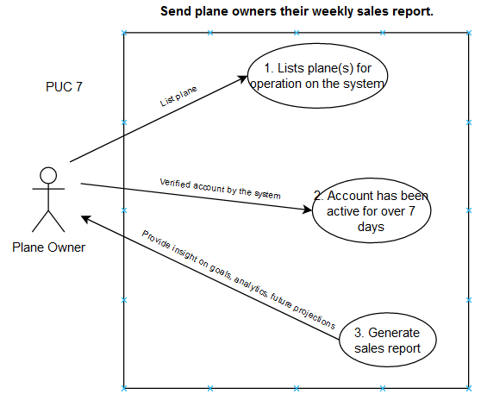

**8. Product Use Case Name:** Give an option to the plane owner to decide on whether the flight will take multiple stops to drop off and pick up passengers on the way to the destination.

**Trigger:** During listing of their plane, the plane owner needs to specify whether they will do multiple stops and drop-offs for passengers along the way.

**Preconditions:** The plane listed by the plane owner should have been approved and scheduled.

**Interested Stakeholders:** Plane owner, Passenger, Airport agents.

**Actor:** Plane owners

1. The plane owner starts a plane listing.
2. The plane listing is approved by the airport and weather departments
3. The plane owner is prompted to enter flight details like allowing multiple stop and drop-offs with the locations, number of seats, other plane details.

**Outcome:** Passengers are pre-informed when they look at the plane details and can decide whether or not they need to contact the plane owner.

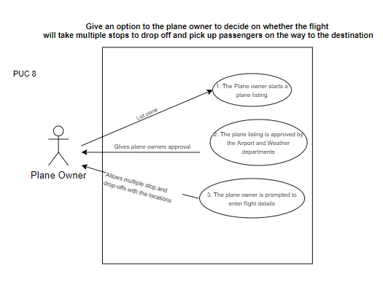

**9. Product Use Case Name:** Create account for the user with FutureAir.

**Trigger:** User wants to create an account with FutureAir.

**Preconditions:** User wants to create an account with FutureAir.

**Interested Stakeholders:** User.

**Actor:** User

1. User clicks on Create Account/Sign Up in the FutureAir main page.
2. Users enter personal information like first name, last name, contact information, date of birth, username, password and other personal information.
3. User is prompted to upload identification documents for verification.
4. If the submitted documents are approved, the user is taken to a page to enter their card details, and successfully have an account created.

**Outcome:** A verified User has an account with FutureAir.



**10. Product Use Case Name:** Let field office agents provide assistance with listings, bookings, and cancellations.

**Trigger:** To deal with customer queries with the product and lead a smooth operation of the product.

**Preconditions:** The field office agents accounts on FutureAir has information about flights and bookings for all users for better customer service.

**Interested Stakeholders:** Passengers, Plane owners, Other users of FutureAir, Field office agents.

**Actor:** Field office agents

1. Field office agents are hired after a background check and trained to work around the system and deal with customer questions.
2. A field office agent account is created that has access to information like flight details about the plane owners, and passenger booking details. Note, there is no personal information like username, password, credit card details of any user with the field office agents.
3. Upon a query about their booking (for passengers) or about the maintenance or scheduling of the flight (for plane owners), the field office agents help the user to provide a good customer service.

**Outcome:** Good customer satisfaction and smooth operation.

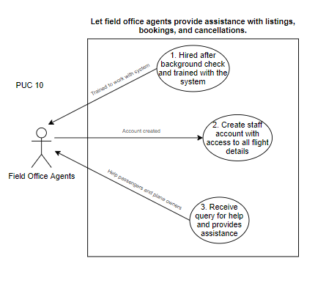

**11. Product Use Case Name:** Allow plane owners toschedule meetings with technicians and engineers for maintenance and inspection.

**Trigger:** The plane owner lists their plane and must complete plane inspection to ensure a safe flight.

**Preconditions:** Plane owner has a plane to list and it has been approved by the airport and weather department for the scheduled day.

**Interested Stakeholders:** Plane owners, Technicians, Engineers.

**Actor:** Plane owner

1. Plane owner’s plane gets approved by the weather station department and the airport it is flying from.
2. The plane owner gets a notification asking them to book a meeting for inspection.
3. The plane owner goes to the “book inspection” page where they enter flight technical details like plane type, model number, engine types, plane company.
4. The plane owner chooses two meetings from the given dates and time; one at least 2 weeks prior to departure and one just the day before the departure to ensure safety of the people on board (The given dates and time are in two parts, one section includes the dates 2 weeks before and the other section only includes time for the day before flight).
5. The plane owner upon booking the two meetings gets a confirmation email and also notification on their FutureAir account. A reminder is sent a day prior to the meeting.

**Outcome:** Plane inspections are done from time to time to ensure safety of all people on board.

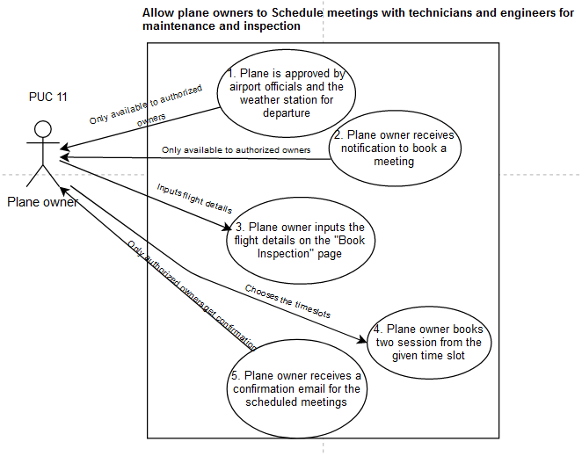

**12. Product Use Case Name:** Reports are available on the product for technicians and engineers to complete plane inspections.

**Trigger:** Prior to plane takeoff and arrival, or when the plane owner would like to complete an inspections, the plane reports must be administered and noted.

**Preconditions:** A plane about to take off or arriving must already be registered with FutureAir so past reports can be given the “all clear” to ensure there are no outstanding issues.

**Interested Stakeholders:** Plane inspectors, security, plane manufacturers, airport inspectors.

**Actor:** Technicians and engineers

1. Previous reports cases are opened.
2. The case files are examined for issues that may cause problems with the future inspections (ex. Loose screws, rust development, etc.).
3. The reports are conducted as planned and improvements are made.
4. The improvements that are made and documented in another report file.
5. The report file is kept in a secure location to protect from intruders.

**Outcome**: Maintains a high level of security for the plane, passengers, and proper documentation for all the things that are right and wrong with the plane.

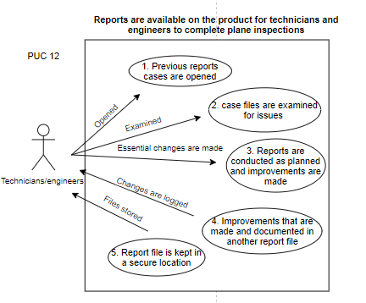

**13. Product Use Case Name:** Before boarding, passenger booking is verified by authorities.

**Trigger:** One the date of departure, the passenger has arrived at the departure gate to board their plane.

**Preconditions:** The user creates an account with FutureAir, uploads their documents for verification, and pays for the booking. Authorities have received a prior notice of the verification of bookings.

**Interested Stakeholders:** Passengers, Immigration authorities.

**Actor:** Immigration officers

1. The passenger arrives at the airport gate for departure.
2. The immigration officers confirm the bookings with the schedules and approved identities of the passengers.
3. The confirmation of the passenger’s booking is recorded in the system.
4. The passenger is notified of the confirmation.
5. The passenger boards the plane.

**Outcome:** Once the immigration officer at the departure gate confirms the passenger’s booking and records the confirmation in the system, the passenger is directed to board the appropriate flight.

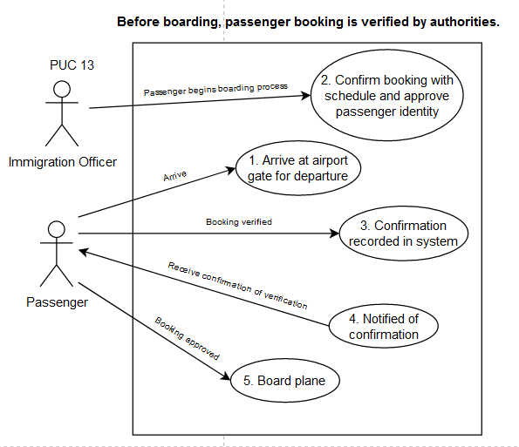

**14. Product Use Case Name:** Accept weather station reports.

**Trigger:** The plane owner lists their plane with the day and time they wish to book the flight.

**Preconditions:** The plane must be listed by the plane owner with the day and time they are planning to book the flight.

**Interested Stakeholders:** Weather station control agents, plane owner, airport agents, authorities.

**Actor:** Weather Station control agents.

1. The plane owner lists a plane with the date and time of expected flight.
2. The date and time details are sent to the weather station.
3. Weather station checks the weather forecast on that day and time, and also for a few days before and after, and writes a report whether it is safe to take a flight.
4. This report is sent to the FutureAir authorities account who are responsible to send the flight details to the airport for confirmation of hangar and runway availability for the particular day and time.

**Outcome:** Plane is only scheduled if it safe to take a flight as per the weather forecast.

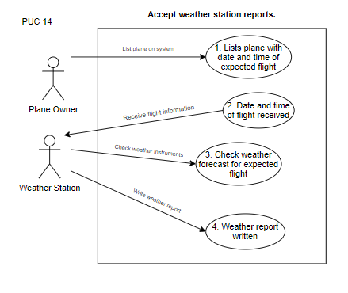

**15. Product Use Case Name:** System sends flight details to airport officials and the airport officials confirm the information.

**Trigger:** Weather station approved of the day and time for the plane listed by the plane owner.

**Preconditions:** Weather station must have approved the plane for the particular day and time.

**Interested Stakeholders:** Airport officials, Airport agents, Weather station, Plane owner, Authorities.

**Actor:** Authorities

1. Once the confirmation and approval is received from the weather station, the authorities send the plane specifications, day and time of flight, destination of the flight, stops and drop-offs locations (if applicable) to the airport.
2. The airport checks for the availability of the hangar and runway space and writes the report. If the day and/or time is not possible, then the airport writes the nearest possible change for the day and time in the report.
3. The report is sent back to the authorities.
4. If approved the plane is scheduled to fly, and the plane owner gets a notification about the approval.
5. If a slight change is required, the plane is scheduled but the plane owner gets a notification about the change. The plane owner can cancel the flight if the changed time is not possible with a valid explanation and reason.

**Outcome:** Plane is scheduled with no barriers.

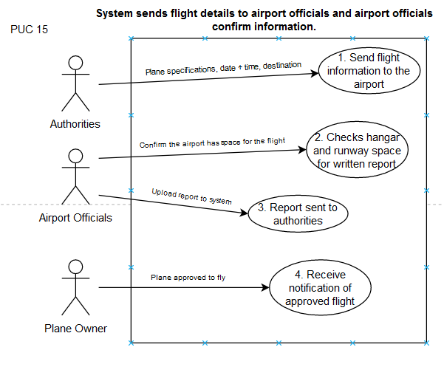

**16. Product Use Case Name:** System must process client payments for a booked flight.

**Trigger:** Passenger books a flight and is asked for payment.

**Preconditions:** Payment has entered valid card and/or bank details for payment in their account information.

**Interested Stakeholders:** Passengers, external payment software being used, plane owner.

**Actor:** Passenger

1. Passenger books a seat on a plane.
2. System prompts the user for payment.
3. Using the already added payment method, the passenger pays for the flight. The passenger may also choose to change their payment method.
4. Upon successful payment processing, the system gives a pop up message saying “payment successful”.

**Outcome:** Successful payment for booked flights is processed.

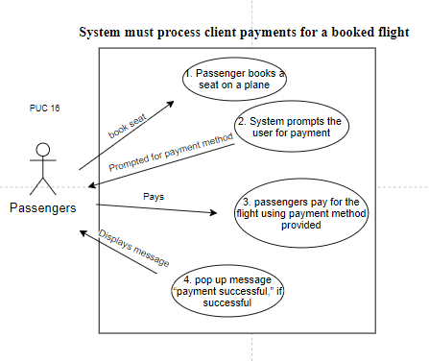

**17. Product Use Case Name:** System must allow plane owners to share reviews of their planes.

**Trigger:** Passenger leaves review and/or rate trips.

**Preconditions:** There are reviews and ratings for the particular plane owner.

**Interested Stakeholders:** Passengers, plane owner.

**Actor:** Plane owner

1. After the flight, the system allows the passenger to leave reviews for that plane owner.
2. The system allows the plane owners to look through all the reviews and ratings for them.
3. The plane owner can choose to add some of the reviews to their main profile page during the flight posting.
4. All reviews will be displayed to any user looking through the plane owner’s profile, but the reviews that the plane owner chooses will be displayed on the top (maximum three).

**Outcome:** Plane owners can add the good reviews about them to the top of their profile.

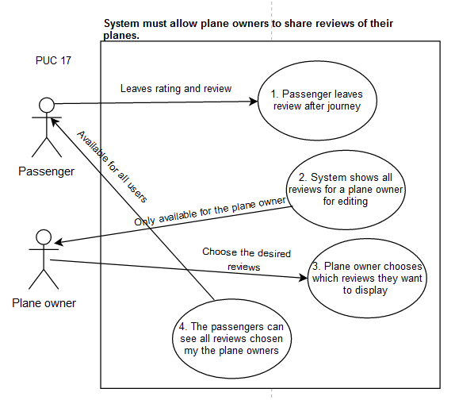

**18. Product Use Case Name:** System must allow plane owners to specify a cancellation fee.

**Trigger:** Any cancellation of ticket by the passenger.

**Preconditions:** Plane owner’s plane should be approved and scheduled.

**Interested Stakeholders:** Passengers, plane owner, External payment software being used.

**Actor:** Plane owner

1. Plane owner gets their plane scheduled.
2. Plane owner lists the specifications and adds cancellation fee in the details.
3. If the passenger cancels the plane ticket then they need to pay the cancellation fee as mentioned.

**Outcome:** Plane owners can add the cancellation fee.

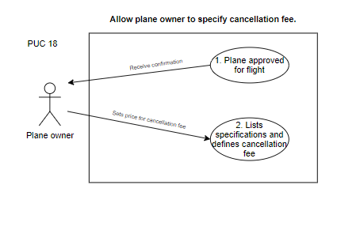

# *Functional Requirements*

| **Requirement #:** 1  **Requirement Type:** 9  **Event/BUC/PUC #:** 1, 2, 14  **Description:** The weather station will transmit details on the weather which will be received by the airport and flight crew.  **Rationale:** To be able to schedule flights according to the weather and avoid accidents.  **Originator:** Punyaja Mishra - Weather station officer.  **Fit Criterion:**Weather measuring instruments must be adjusted prior to taking precise temperature and wind readings before scheduling every flight.  **Customer Satisfaction:** 3  **Customer Dissatisfaction:** 5  **Dependencies:** All requirements regarding the operation of the flight.  **Conflicts:** 9  **Supporting Materials:** Work context diagram, data dictionary.  **History:** Created December 1, 2020 |
| --- |

| **Requirement #:** 2  **Requirement Type:** 9  **Event/BUC/PUC #:** 2, 20, 15  **Description:** Planes will take off and arrive at airports and have a designated area to park the aircraft.  **Rationale:**  **Originator:** Sarah Roy - Airport Control Agent.  **Fit Criterion:** Planes must be assigned a designated area for parking the aircraft specified in an updated schedule for all airport control officers.  **Customer Satisfaction:** 2  **Customer Dissatisfaction:** 5  **Dependencies:** All requirements regarding the scheduling of allocated hangar space.  **Conflicts:** 6  **Supporting Materials:** Work context diagram, data dictionary.  **History:** Created December 1, 2020 |
| --- |

| **Requirement #:** 3  **Requirement Type:** 9  **Event/BUC/PUC #:** 3, 3, 10  **Description:** Field office agents provide assistance with plane listings, bookings, and cancellations.  **Rationale:** Improving customer satisfaction and experience by helping them with bookings, cancellations or any queries.  **Originator:** Punyaja Mishra - Field office agents hiring manager.  **Fit Criterion:** No bad review by a customer/passenger/user against FutureAir.  **Customer Satisfaction:** 5  **Customer Dissatisfaction:** 3  **Dependencies:** All requirements regarding a scheduled plane listing.  **Conflicts:** *no conflicts* (it is a customer service being provided by FutureAir).  **Supporting Materials:** Work context Diagram, data dictionary.  **History:** Creator December 2, 2020 |
| --- |

| **Requirement #:** 4  **Requirement Type:** 9  **Event/BUC/PUC #:** 4, 5, 11  **Description:** Technicians and engineers complete inspections and reports.  **Rationale:** Plane inspection is required to ensure safety and smooth operation of flights.  **Originator:** Punyaja Mishra - Chief technician.  **Fit Criterion:** The inspection reports by the technicians and engineers shall agree with the plane owner’s maintenance reports and be up to date before every flight.  **Customer Satisfaction:** 5  **Customer Dissatisfaction:** 4  **Dependencies:** All requirements regarding the particular scheduled plane listing.  **Conflicts:** 6, 10, 13, 15  **Supporting Materials:** Work Context Diagram, data dictionary.  **History:** Created December 2, 2020 |
| --- |

| **Requirement #:** 5  **Requirement Type:** 9  **Event/BUC/PUC #:** 5, 7, 13  **Description:** Authorities verify booking with the system.  **Rationale:** Standard procedure to confirm the passenger has the right booking before boarding the flight and gives the passenger the confirmation that they will be boarding their respective flight.  **Originator:** Punyaja Mishra - Head Authority.  **Fit Criterion:** Passengers with right booking are boarded on the right plane with customer satisfaction that they will be boarding their respective flight.  **Customer Satisfaction:** 5  **Customer Dissatisfaction:** 3  **Dependencies:** Requirement concerning sending weekly sales report to the plane owners, Requirement about passengers using the system to leave reviews and rate trips.  **Conflicts:** *no conflicts (*irrespective whether passengers bookings are verified or not, passengers are able to board a flight leading to every requirement taking place).  **Supporting Materials:** Work Context Diagram, data dictionary.  **History:** Created December 2, 2020 |
| --- |

| **Requirement #:** 6  **Requirement Type:** 9  **Event/BUC/PUC #:** 6. 9, 11  **Description:** Fuel company booked by the plane owner provides fuel for all planes.  **Rationale:** Plane requires fuel to take flight.  **Originator:** Punyaja Mishra - Plane owner  **Fit Criterion:** Inspection and maintenance reports of the planes shall have log about the scheduled time when fueling of the plane is taking place.  **Customer Satisfaction:** 5  **Customer Dissatisfaction:** 4  **Dependencies:** Plane taking a flight.  **Conflicts:** 4, 11  **Supporting Materials:** Work Context Diagram, data dictionary.  **History:** Created December 2, 2020 |
| --- |

| **Requirement #:** 7  **Requirement Type:** 9  **Event/BUC/PUC #:** 7, 10, 1  **Description:** Passengers upload travel documents to verify identity.  **Rationale:** To be able to ensure safety of all the users of FutureAir and passengers and protecting against any possible breach or danger.  **Originator:** Punyaja Mishra - Security Head.  **Fit Criterion:** Every user with an account in FutureAir shall be verified before granting access to their account with FutureAir.  **Customer Satisfaction:** 5  **Customer Dissatisfaction:** 3  **Dependencies:** All requirements with a working passenger user account in FutureAir.  **Conflicts:** 10, 12, 13, 14  **Supporting Materials:** Work Context Diagram, data dictionary.  **History:** Created December 2, 2020 |
| --- |

| **Requirement #:** 8  **Requirement Type:** 9  **Event/BUC/PUC #:** 8, 10, 5  **Description:** Plane owners upload documents to verify identity.  **Rationale:** To be able to ensure safety of all the users of FutureAir and passengers and protecting against any possible breach or danger.  **Originator:** Punyaja Mishra - Security Head.  **Fit Criterion:** Every user with an account in FutureAir shall be verified before granting access to their account with FutureAir.  **Customer Satisfaction:** 5  **Customer Dissatisfaction:** 4  **Dependencies:** All requirements with a working plane owner user account in FutureAir.  **Conflicts:** 2, 3, 4, 5, 6, 9, 11, 13, 15, 17  **Supporting Materials:** Work Context Diagram, data dictionary.  **History:** Created December 2, 2020 |
| --- |

| **Requirement #:** 9  **Requirement Type:** 9  **Event/BUC/PUC #:** 9, 16, 6  **Description:** Plane owners list their plane with the specifications of the aircraft.  **Rationale:** To be able to provide flights and better customer service to the passengers by providing more details about the plane.  **Originator:** Punyaja Mishra - Plane owner.  **Fit Criterion:** Passengers shall have immense amounts of choices for choosing a flight given the fact plane owners can list their planes.  **Customer Satisfaction:** 4  **Customer Dissatisfaction:** 3  **Dependencies:** All requirements regarding plane owners’ planes.  **Conflicts:** 2, 3, 4, 5, 6, 9, 11, 13, 15, 17  **Supporting Materials:** Work Context Diagram, data dictionary.  **History:** Created December 2, 2020 |
| --- |

| **Requirement #:** 10  **Requirement Type:** 9  **Event/BUC/PUC #:** 10, 11, 2  **Description:** Passengers use the system to search available flights.  **Rationale:** To be able to provide passengers the ability to book their own flights as per their convenience.  **Originator:** Punyaja Mishra - plane owner.  **Fit Criterion:** The listed scheduled plane’s owners will be able to achieve many passengers and earn a good amount of money.  **Customer Satisfaction:** 5  **Customer Dissatisfaction:** 3  **Dependencies:** All requirements regarding passengers booking flights.  **Conflicts:** 13  **Supporting Materials:** Work Context Diagram, data dictionary.  **History:** Created December 2, 2020 |
| --- |

| **Requirement #:** 11  **Requirement Type:** 9  **Event/BUC/PUC #:** 11, 9, 11  **Description:** Technicians and engineers hired for maintenance or inspections of the planes.  **Rationale:** Plane inspection is required to ensure safety and smooth operation of flights  **Originator:** Punyaja Mishra - Chief technician hiring manager.  **Fit Criterion:** The technicians and engineers shall be hired to make inspection reports that agree with the plane owner’s maintenance reports and be up to date before every flight.  **Customer Satisfaction:** 3  **Customer Dissatisfaction:** 3  **Dependencies:** All requirements regarding inspection of the scheduled plane and that plane listing.  **Conflicts:** 4, 6, 10, 13, 15  **Supporting Materials:** Work Context Diagram, data dictionary.  **History:** Created December 2, 2020 |
| --- |

| **Requirement #:** 12  **Requirement Type:** 9  **Event/BUC/PUC #:** 12, 8, 5  **Description:** Passenger information is shared with authorities for international flights.  **Rationale:** Passengers must be prompted to upload identification documents for verification after paying for their booking with FutureAir. These documents are then sent within the system to airport authority commissioners who review and verify these documents.  **Originator:** Sarah Roy - Airport Commissioner.  **Fit Criterion:** Passenger information must be uploaded into the FutureAir website or application using their account.  **Customer Satisfaction:** 3  **Customer Dissatisfaction:** 5  **Dependencies:** All requirements regarding the passengers booking flights.  **Conflicts:** 7  **Supporting Materials:** Work Context Diagram, data dictionary.  **History:** Created December 2, 2020 |
| --- |

| **Requirement #:** 13  **Requirement Type:** 9  **Event/BUC/PUC #:** 13, 12, 2  **Description:** Passengers view the available flights along with the number of seats on the plane and the price of the flight.  **Rationale:** The customers should be given the option to pick their seats and preference to sit based on the price (first class, economy, etc).  **Originator:** Abhinav Manocha - Airport system manager.  **Fit Criterion:** The passengers shall be given a fixed time frame to select their seats and pricing in order to book their reservation on the flight.  **Customer Satisfaction:** 3  **Customer Dissatisfaction:** 3  **Dependencies:** All requirements regarding passengers booking flights.  **Conflicts:** 16  **Supporting Materials:** Work Context Diagram, data dictionary.  **History:** Created December 2, 2020 |
| --- |

| **Requirement #:** 14  **Requirement Type:** 9  **Event/BUC/PUC #:** 14, 13, 3  **Description:** Passengers use the system to leave reviews and rate trips.  **Rationale:** To be able to leave reviews and have their experience valued and respected.  **Originator:** Abhinav Manocha - Review expert.  **Fit Criterion:** The passenger will have the option of reviewing their experience of the flight to share with the world in under 140 characters. This will allow for ample space to express their opinions.  **Customer Satisfaction:** 3  **Customer Dissatisfaction:** 3  **Dependencies:** All requirements regarding passengers completing the trip.  **Conflicts:** 22  **Supporting Materials:** Work Context Diagram, data dictionary.  **History:** Created December 2, 2020 |
| --- |

| **Requirement #:** 15  **Requirement Type:** 9  **Event/BUC/PUC #:** 15, 17, 8  **Description:** Plane owners decide whether the flight will take multiple stops to drop off and pick up passengers on the way to the destination.  **Rationale:** There may be other passengers that need to be picked up along the way as this service is similar to a rideshare. There is no limit to how many passengers can be picked up along the ride.  **Originator:** Abhinav Manocha - Plane manager.  **Fit Criterion:** The passengers must agree to stop at however many stops are required before reaching the final destination.  **Customer Satisfaction:** 4  **Customer Dissatisfaction:** 4  **Dependencies:** All requirements regarding plane owners willingness to pick up other customers through the duration of the trip.  **Conflicts:** N/A.  **Supporting Materials:** Work Context Diagram, data dictionary.  **History:** Created December 2, 2020 |
| --- |

| **Requirement #:** 16  **Requirement Type:** 9  **Event/BUC/PUC #:** 16, 14, 4  **Description:** System prompts account holders to re-enter their password after one idle minute on the application or website.  **Rationale:** If the system that has been logged into by a user and experienced no activity for one minute, the system must prompt the passenger to re-enter their login credentials to continue using their account on the system for security reasons.  **Originator:** Sarah Roy - Security Head.  **Fit Criterion:** The user must have an account with FutureAir, logged into the FutureAir account on the application or website, one minute of inactivity by the account holder.  **Customer Satisfaction:** 2  **Customer Dissatisfaction:** 4  **Dependencies:** All requirements regarding the registration, login and security of the system.  **Conflicts:** N/A.  **Supporting Materials:** Work Context Diagram, data dictionary.  **History:** Created December 2, 2020 |
| --- |

| **Requirement #:** 17  **Requirement Type:** 9  **Event/BUC/PUC #:** 17, 18, 7  **Description:** Plane owners receive weekly sales reports.  **Rationale:** Plane owners can keep track of the profitability of their planes and services with the weekly sales reports generated by the FutureAir website.  **Originator:** Sarah Roy - Chief Report officer.  **Fit Criterion:** Planes and plane owners must be registered with a FutureAir account for at least 7 calendar days.  **Customer Satisfaction:** 3  **Customer Dissatisfaction:** 5  **Dependencies:** All requirements regarding the tracking of sales for each plane.  **Conflicts:** N/A.  **Supporting Materials:** Work Context Diagram, data dictionary.  **History:** Created December 2, 2020 |
| --- |

| **Requirement #:** 18  **Requirement Type:** 9  **Event/BUC/PUC #:** 18, 21, 16  **Description:** System must process client payments for a booked flight.  **Rationale:** The FutureAir website must provide the passengers with a safe and secure platform to redirect their payments through online banking with the bank of their choice.  **Originator:** Sarah Roy - Chief financial officer with FutureAir.  **Fit Criterion:** The user must have an account with FutureAir, logged into the FutureAir account on the application or website, all identification documents must be uploaded.  **Customer Satisfaction:** 4  **Customer Dissatisfaction:** 4  **Dependencies:** All requirements regarding the registration, login and security of the system.  **Conflicts:** 16, 23  **Supporting Materials:** Work Context Diagram, data model, data dictionary.  **History:** Created December 2, 2020 |
| --- |

| **Requirement #:** 19  **Requirement Type:** 9  **Event/BUC/PUC #:** 19, 22, 17  **Description:** System must allow plane owners to share reviews of their planes.  **Rationale:** Plane owners can choose which of their reviews they want to display on the plane description.  **Originator:** Sarah Roy - Passenger giving reviews.  **Fit Criterion:** The user must have an account with FutureAir, logged into the FutureAir account on the application or website, all identification documents must be uploaded, the plane must have been in operation for at least 7 business days.  **Customer Satisfaction:** 2  **Customer Dissatisfaction:** 4  **Dependencies:** All requirements regarding the registration, login and security of the system.  **Conflicts:** 13  **Supporting Materials:** Work Context Diagram, data dictionary.  **History:** Created December 2, 2020 |
| --- |

| **Requirement #:** 20  **Requirement Type:** 9  **Event/BUC/PUC #:** 20, 23, 18  **Description:** System must allow plane owners to specify a cancellation fine.  **Rationale:** The FutureAir website must allow the plane owners to specify a cancellation fine for cancelled bookings.  **Originator:** Sarah Roy - Plane owners (giving specifications).  **Fit Criterion:** The plane owner must have an account with FutureAir, logged into the FutureAir account on the application or website, all identification documents must be uploaded and verified.  **Customer Satisfaction:** 2  **Customer Dissatisfaction:** 4  **Dependencies:** All requirements regarding the registration, login and security of the system.  **Conflicts:** 16, 21  **Supporting Materials:** Work Context Diagram, data dictionary.  **History:** Created December 2, 2020 |
| --- |

# *Non-Functional Requirements*

## **Look and Feel Requirements**

| **Requirement #:** 21  **Requirement Type:** 10  **Description:** The product should be compliant with the branding standards of the client’s company.  **Rationale:** For customers to be able to identify and associate the product with the company.  **Originator:** Cassandra Yoo - Marketing Manager.  **Fit Criterion:** The product has been approved by individuals from the company and thematically connect with the branding of the company.  **Customer Satisfaction:** 3  **Customer Dissatisfaction:** 3  **Dependencies:** Any marketing, branding, or posting of the product on social media or any other platform.  **Conflicts:** N/A.  **Supporting Materials:** Work Context Diagram, data dictionary.  **History:** Created December 2, 2020 |
| --- |

## **Usability and Humanity Requirements**

| **Requirement #:** 22  **Requirement Type:** 11  **Description:** The product should be easy to use.  **Rationale:** In order to target the largest audience, it should be straightward to use and navigate.  **Originator:** Cassandra Yoo - Client/Developer.  **Fit Criterion:** The product should have clearly labelled buttons, links, and pages to make it easy for all people of legal ages to navigate.  **Customer Satisfaction:** 5  **Customer Dissatisfaction:** 4  **Dependencies:** All users using the application or website.  **Conflicts:** N/A.  **Supporting Materials:** Work Context Diagram, data dictionary.  **History:** Created December 3, 2020 |
| --- |

| **Requirement #:** 23  **Requirement Type:** 11  **Description:** The product should be easy to learn.  **Rationale:** To keep customers using this product, it should be easy to adapt to.  **Originator:** Cassandra Yoo - Developer, building a good non-complex interface.  **Fit Criterion:** A first time user should be able to navigate through the website or application and find what they are searching for within 5 minutes.  **Customer Satisfaction:** 5  **Customer Dissatisfaction:** 4  **Dependencies:** All users using the application or website.  **Conflicts:** N/A.  **Supporting Materials:** Work Context Diagram, data dictionary.  **History:** Created December 3, 2020 |
| --- |

| **Requirement #:** 24  **Requirement Type:** 11  **Description:** The product should be accessible to all users.  **Rationale:** To provide the product to the maximum number of users possible.  **Originator:** Cassandra Yoo - Marketing manager and developer to ensure that interface is good to use for all age groups and users with many deficiencies.  **Fit Criterion:** Users with physical or mental disabilities should be able to use the product with no assistance from others.  **Customer Satisfaction:** 5  **Customer Dissatisfaction:** 5  **Dependencies:** All users using the application or website.  **Conflicts:** N/A.  **Supporting Materials:** Work Context Diagram, data dictionary.  **History:** Created December 3, 2020 |
| --- |

## **Performance Requirements**

| **Requirement #:** 25  **Requirement Type:** 12  **Description:** The product should have the capacity to handle 5000 users simultaneously.  **Rationale:** The system should be able to handle many users from different locations all at once.  **Originator:** Abhinav Manocha - Developers.  **Fit Criterion:** The application or website will continue to run smoothly and users will receive search results within 30 seconds.  **Customer Satisfaction:** 3  **Customer Dissatisfaction:** 4  **Dependencies:** All users.  **Conflicts:** N/A.  **Supporting Materials:** Work Context Diagram, data dictionary.  **History:** Created December 3, 2020 |
| --- |

| **Requirement #:** 26  **Requirement Type:** 12  **Description:** The product should run on both web and mobile apps.  **Rationale:** Not all users will have a computer, or mobile device, or both.  **Originator:** Abhinav Manocha- Developers.  **Fit Criterion:** A user should be able to use the product, book flights, write reviews, and complete all other features on any device.  **Customer Satisfaction:** 5  **Customer Dissatisfaction:** 5  **Dependencies:** All users using the product, all common web browsers, iOS and Android.  **Conflicts:** N/A.  **Supporting Materials:** Work Context Diagram, data dictionary.  **History:** Created December 3, 2020 |
| --- |

| **Requirement #:** 27  **Requirement Type:** 12  **Description:** The product should be available to run on all available browsers.  **Rationale:** Anyone using the product should have the option to run it on any popular and common browser window.  **Originator:** Cassandra Yoo - Developers/Client.  **Fit Criterion:** Browsers are including but not limited to Chrome, Safari, Firefox, and Edge.  **Customer Satisfaction:** 5  **Customer Dissatisfaction:** 4  **Dependencies:** the entire product running so all requirements.  **History:** Created December 3, 2020 |
| --- |

| **Requirement #:** 28  **Requirement Type:** 12  **Description:** The product should provide search results for flights fast.  **Rationale:** To prevent users from getting frustrated or quitting, results should be displayed quickly enough that the user will continue to use the product.  **Originator:** Cassandra Yoo - Developers.  **Fit Criterion:** The website or application should display search results for flights within 30 seconds.  **Customer Satisfaction:** 4  **Customer Dissatisfaction:** 4  **Dependencies:** the entire operation of the system.  **Conflicts:** N/A.  **Supporting Materials:** Work Context Diagram, data dictionary.  **History:** Created December 3, 2020 |
| --- |

| **Requirement #:** 29  **Requirement Type:** 12  **Description:** The product should be fault tolerant and should work properly even in cases where there is an overload on the network due to large volume of users.  **Rationale:** Small mistakes should not crash the system.  **Originator:** Cassandra Yoo - Developers.  **Fit Criterion:** Pages should still load within 30 seconds even with a large volume of users.  **Customer Satisfaction:** 4  **Customer Dissatisfaction:** 4  **Dependencies:** The entire operation of the system - so all requirements.  **Conflicts:** N/A.  **Supporting Materials:** Work Context Diagram, data dictionary.  **History:** Created December 3, 2020 |
| --- |

## **Operational and Environmental Requirements**

| **Requirement #:** 30  **Requirement Type:** 13  **Description:** The product should allow auditors to audit the financial, flight, and accounting data.  **Rationale:** The people getting paid for using the product should be compensated fairly and legally.  **Originator:** Abhinav Manocha- Developers and financial advisors to specify the correct process or software.  **Fit Criterion:** Plane owners will receive weekly reports on the details of the flights using their aircrafts and all workers under the system will be paid bi-weekly.  **Customer Satisfaction:** 5  **Customer Dissatisfaction:** 5  **Dependencies:** All requirements regarding financial transactions.  **Conflicts:** N/A.  **Supporting Materials:** Work Context Diagram, data dictionary.  **History:** Created December 3, 2020 |
| --- |

## **Maintainability and Support Requirements**

| **Requirement #:** 31  **Requirement Type:** 14  **Description:** The product should require maximum maintenance of 2 hours every 3 months.  **Rationale:** Maintenance of the system is required for ensuring the security and integrity of the system. Maintenance requirements also allows the proper updates to be installed.  **Originator:** Sarah Roy - Maintenance Agent.  **Fit Criterion:** The system will notify all users of a down period during maintenance ahead of time to prevent any inconvenience.  **Customer Satisfaction:** 2  **Customer Dissatisfaction:** 2  **Dependencies:** All requirements regarding maintenance of the system.  **Conflicts:** N/A.  **Supporting Materials:** Work Context Diagram, data dictionary.  **History:** Created December 3, 2020 |
| --- |

## **Security Requirements**

| **Requirement #:** 32  **Requirement Type:** 15  **Description:** The product should ensure the security and integrity of data.  **Rationale:** The FutureAir system, website and application should uphold the security standard, decrease vulnerabilities and prevent any breaches or attacks, because user information is important.  **Originator:** Punyaja Mishra - Security Head.  **Fit Criterion:** Asking users for re-entering password after 1 minute of inactivity to ensure protection of personal information of the user.  **Customer Satisfaction:** 5  **Customer Dissatisfaction :** 5  **Dependencies:** All requirements including entering of personal information, user inactivity.  **Conflicts:** N/A.  **Supporting Materials:** Work Context Diagram, data dictionary.  **History:** Created December 3, 2020 |
| --- |

| **Requirement #:** 33  **Requirement Type:** 15  **Description:** The product should ensure the privacy of users’ personal data.  **Rationale:** All users should feel safe sharing their personal information with the product.  **Originator:** Abhinav Manocha- Security Head.  **Fit Criterion:** There should be multiple levels of security behind the databases holding personal information and users should have the option to immediately change their personal information if there is any sign of a breach. Will also include 2-factor authentication.  **Customer Satisfaction:** 5  **Customer Dissatisfaction:** 5  **Dependencies:** All users using the system including passengers, plane owners, and staff.  **Conflicts:** N/A.  **Supporting Materials:** Work Context Diagram, data dictionary.  **History:** Created December 3, 2020 |
| --- |

## **Cultural Requirements**

| **Requirement #:** 34  **Requirement Type:** 16  **Description:** The product should not be offensive to any religion or ethnic group.  **Rationale:** To respect users of all ethnicities, cultures, races, and religions.  **Originator:** Cassandra Yoo - Developers.  **Fit Criterion:** The product will not show any favouritism, bias, or discrimination against any ethnic group or religion in order for it to be suitable to all demographics.  **Customer Satisfaction:** 5  **Customer Dissatisfaction:** 5  **Dependencies:** Vulnerable groups and communities - customer dissatisfaction is VERY important.  **Conflicts:** N/A.  **Supporting Materials:** Work Context Diagram, data dictionary.  **History:** Created December 3, 2020 |
| --- |

| **Requirement #:** 35  **Requirement Type:** 16  **Description:** The product should be available in both English and French.  **Rationale:** Based in Canada, it should provide service for both languages of the country.  **Originator:** Cassandra Yoo - Developers.  **Fit Criterion:** Upon opening the application or website, there should be an option to choose to view the content in either English or French.  **Customer Satisfaction:** 4  **Customer Dissatisfaction:** 4  **Dependencies:** All requirements of the product.  **Conflicts:** N/A.  **Supporting Materials:** Work Context Diagram, data dictionary  **History:** Created December 3, 2020 |
| --- |

## **Legal Requirements**

| **Requirement #:** 36  **Requirement Type:** 17  **Description:** The product should be fully compliant with the privacy laws of Canada.  **Rationale:** The product should not violate any laws and maintain privacy for the comfort of users.  **Originator:** Sarah Roy - System legal advisors at FutureAir.  **Fit Criterion:** The product should meet all the required guidelines set by the Government of Canada.  **Customer Satisfaction:** 5  **Customer Dissatisfaction:** 5  **Dependencies:** Anything with the product that pertains to privacy.  **Conflicts:** N/A.  **Supporting Materials:** Criminal Code of Canada, data dictionary, work context diagram.  **History:** Created December 3, 2020 |
| --- |

# *Project Issues*

## **Open Issues**

* There is uncertainty if there could be problems at the international borders for international flights
* No standard measures have been established for performance assessment
* There is an uncertainty around the fact of how the plane owners will handle transportation of their planes to the airports
* The number of plane inspections required and adequate to ensure safety is still ambiguous
* The product contacts both the weather department and the airport for confirming the scheduling of the plane, which increases the response time. Any relations between airport and weather stations are still unexplored to improve response rate.
* Actions that should be taken if the identification documents are rejected by the authorities are ambiguous.
* Number of technicians and engineers hired for maintenance and inspection along with their location availability is ambivalent
* Steps to be taken when a plane owner decides to cancel a flight 3 weeks or less prior to the departure.

## **Off the Shelf Solutions**

*Ready-Made Products*

* Existing database software being used
* Existing payment processing softwares being used for user payments
* In case of issues, contracts with external security agencies
* Payroll tax processing software for payments to agents and staffs working for FutureAir

*Reusable Components*

* Outsourcing security solutions from our previous projects for the system

*Products That Can be Copied*

* Inspection and maintenance reports from past maintenance checks for the particular plane
* The Microsoft Office suit and Gmail for communication between the plane owners and passengers, or plane owners and staff.

## **Risks Assessment**

The probability of a risk can be low, moderate, or high. The effect of a risk can be insignificant, tolerable, serious, or catastrophic.

*Technology*

**1. Risk:** App/website may crash due to high volume of traffic.

**Probability:** Low.

**Effect:** Tolerable. Passengers may experience frustration when the system lags or in a more serious case, miss a flight and receive compensation.

**2. Risk:** Insufficient code or a slow server/system.

**Probability:** Low.

**Effect:** Tolerable.Insufficient code can lead to poor performance of the system. A slow server could decrease the usage of the application. In extreme cases, the system would experience a temporary shutdown.

**3. Risk:** System Hijacking.

**Probability:** Moderate.

**Effect:** Catastrophic.Security concerns of private information pertaining to the passengers**,** plane owners and other persons of interest.

*People/Security*

**1. Risk:** Private information leaked and/or data mined.

**Probability:** Low.

**Effect:** Catastrophic. Any security breach where private information is leaked can have serious consequences on the company and users may take legal action.

**2. Risk:** Shortage of staff due to illness or unforeseen circumstances.

**Probability:** Low.

**Effect:** Insignificant. Employee absence for short periods of time will not impact the system quality or extend the deadline of the project.

*Organizational*

**1. Risk:** Lack of project management.

**Probability:** Low.

**Effect:** Serious. Project may fall behind and not launch by the February 2021 deadline.

**2. Risk:** Unrealistic schedule.

**Probability:** Moderate.

**Effect:** Tolerable. Some compromises between level of detail and time must be made to present a complete project by the deadline.

*Tools*

**1. Risk:** Software Restrictions.

**Probability:** Low.

**Effect:** Tolerable.Different software could restrict developers from ownership, distribution and execution.

**2. Risk:** Difference in international censorship laws/restrictions.

**Probability:** High.

**Effect:** Tolerable.Censorship laws can vary from country to country which dictate the features or softwares that can be used in the application.

*Requirements*

**1. Risk:** Oversight of details not present at the beginning of the project that emerge in

later stages of development.

**Probability:** Moderate.

**Effect:** Tolerable. New problems are constantly emerging and the development team may have to change their schedule to fit in time to work on additional components of the project.

**2. Risk:** Private information leaked and/or data mined.

**Probability:** Low.

**Effect:** Catastrophic. Any security breach where private information is leaked can have serious consequences on the company and users may take legal action.

## 

## **Costs**

*Function Points*

Input

1. **Weather station provides weather details.** 
   1. Attributes: weather station ID, temperature, date, time, pilot ID
   2. Classes: weather station, airport, pilot
   3. Function Points: 6
   4. Final cost estimation: (Function points/150) * function points ^ 0.4 = 0.081 hours
2. **Airport provides hangar space for planes.**
   1. Attributes: airport code, airport name, plane ID
   2. Classes: airport, plane
   3. Function Points: 3
   4. Effort in staff months: (Function points/150) * function points ^ 0.4 = 0.031 hours
3. **Field office agents provide assistance with plane listings, bookings, and cancellations.**
   1. Attributes: plane ID, available seats, booking ID, owner ID, passenger ID
   2. Classes: passenger, plane owner, field office agent
   3. Function Points: 6
   4. Effort in staff months: (Function points/150) * function points ^ 0.4 = 0.08 hours
4. **Technicians and engineers complete inspections and reports.**
   1. Attributes: engineer ID, maintenance form ID, maintenance ID, plane ID, airport code
   2. Classes: technicians/engineers
   3. Function Points: 4
   4. Effort in staff months: (Function points/150) * function points ^ 0.4 = 0.046 hours
5. **Authorities verify booking with the system.**
   1. Attributes: passenger ID, passport number, booking ID,
   2. Classes: authorities, passenger
   3. Function Points: 3
   4. Effort in staff months: (Function points/150) * function points ^ 0.4 = 0.031 hours
6. **Fuel company provides fuel for all planes.**
   1. Attributes: plane ID, airport code, maintenance ID
   2. Classes: field engineers, plane, fuel company
   3. Function Points: 4
   4. Effort in staff months: (Function points/150) * function points ^ 0.4 = 0.046 hours
7. **Passengers upload travel documents to verify identity.**
   1. Attributes: passenger ID, passport number, booking ID
   2. Classes: passenger, authorities
   3. Function Points: 3
   4. Effort in staff months: (Function points/150) * function points ^ 0.4 = 0.031 hours
8. **Plane owners upload documents to verify identity.**
   1. Attributes: owner ID, plane ID, pilot ID
   2. Classes: plane owner, plane
   3. Function Points: 3
   4. Effort in staff months: (Function points/150) * function points ^ 0.4 = 0.031 hours
9. **Plane owners list their plane with the specifications of the aircraft.** 
   1. Attributes: owner ID, plane ID, pilot ID, available seats
   2. Classes: plane owner, plane
   3. Function Points: 3
   4. Effort in staff months: (Function points/150) * function points ^ 0.4 = 0.031 hours
10. **Passengers use the system to search available flights.**
    1. Attributes: passenger ID, airport code, departure airport, arrival airport, departure time, arrival time
    2. Classes: passenger, airport
    3. Function Points: 4
    4. Effort in staff months: (Function points/150) * function points ^ 0.4 = 0.046 hours

Output

1. **Technicians and engineers hired for maintenance or inspections of the planes.**
   1. Attributes: plane ID, maintenance ID, maintenance form ID, engineer ID, airport ID
   2. Classes: technicians/engineers
   3. Function Points: 4
   4. Effort in staff months: (Function points/150) * function points ^ 0.4 = 0.046 hours
2. **Passenger information is shared with authorities for international flights.**
   1. Attributes: passenger ID, passport number, booking ID, plane ID, departure airport, arrival airport, airport code
   2. Classes: passenger, authorities, airport
   3. Function Points: 5
   4. Effort in staff months: (Function points/150) * function points ^ 0.4 = 0.063 hours
3. **Passengers view the available flights along with the number of seats on the plane and the price of the flight.**
   1. Attributes: passenger ID, plane ID, available seats, price, departure airport, arrival airport, departure time, arrival time
   2. Classes: passenger, plane
   3. Function Points: 5
   4. Effort in staff months: (Function points/150) * function points ^ 0.4 = 0.063 hours

Time-Triggered

1. **Passengers use the system to leave reviews and rate trips.**
   1. Attributes: passenger ID, plane ID, owner ID, booking ID, date
   2. Classes: passenger, plane owner
   3. Function Points: 3
   4. Effort in staff months: (Function points/150) * function points ^ 0.4 = 0.031 hours
2. **Plane owners decide whether the flight will take multiple stops to drop off and pick up passengers on the way to the destination.** 
   1. Attributes: passenger ID, plane ID, owner ID, booking ID, departure time, arrival time, departure airport, arrival airport, date
   2. Classes: plane owner, plane, airport, passenger
   3. Function Points: 4
   4. Effort in staff months: (Function points/150) * function points ^ 0.4 = 0.046 hours
3. **System prompts passengers to re-enter their password after one idle minute on the application or website.**
   1. Attributes: passenger ID, name, email, password, time, date
   2. Classes: passenger
   3. Function Points: 3
   4. Effort in staff months: (Function points/150) * function points ^ 0.4 = 0.031 hours
4. **Plane owners receive weekly sales reports.**
   1. Attributes: owner ID, plane ID, name, report number, date
   2. Classes: owner, plane
   3. Function Points: 3
   4. Effort in staff months: (Function points/150) * function points ^ 0.4 = 0.031 hours
5. **System prompts plane owners to re-enter their password after one idle minute on the application or website.**
   1. Attributes: owner ID, name, email, password, time, date
   2. Classes: owner
   3. Function Points: 3
   4. Effort in staff months: (Function points/150) * function points ^ 0.4 = 0.031 hours

Estimation

**1. Risk:** Time required to develop the software is underestimated.

**Probability:** Low.

**Effect:** Tolerable. Development deadlines will be extended and will delay the launch date of the project.

**2. Risk:** Going over budget.

**Probability:** Moderate.

**Effect:** Tolerable. Slightly over budget will not hinder the success of the company.

## **Ideas for Solutions**

* FutureAir could provide transportation for the passengers from their home to the airport from where the departure is, if they are unable to find their own ride.
* FutureAir could collaborate with plane owners for a few deals and discounts like low kid/student prices, complimentary care packages and many more. These should be optional as per the convenience of the plane owner.
* Alliance with one fuel company could lead to a better update of the maintenance reports and smoother operations.
* Transportation could be provided to the inspection and maintenance engineers to reach the place with the plane owner’s planes
* The technicians and maintenance engineers could have an option in their account on the application/website, where they can enter services for reimbursement (like transportation and food services, with a proof like a receipt)
* In-build communication services like chat, or call for easier communication between the users without giving personal contact information
* Having “optional notification services” in the product so the users are notified about important information like upcoming events, payments, etc, even if they have their notifications turned off for the application.